**New Installer Experience**

**RAIDER HUB**

Recommended Approach

|  |  |
| --- | --- |
| Authors: | Arcucci, Giuliano  Baravaglio, Mario  Rodriguez, Matias Nicolas  Sanchez, Juan Manuel  Trippel Nagel, Juan Manuel |

Table of contents

**Investigation Summary** **3**

State of Rockwell Automation’s tools 3

**HUB Objective** **3**

**HUB Scope** **4**

Life cycle 4

Identity and Authorization management 5

Project launcher 6

Extensions life cycle 6

Digital content (learn, news) 7

**High-level architecture** **7**

HUB service 9

Package Management System 10

Packaging 11

Npm (Node package manager) 11

Microsoft install technologies 13

Proprietary install technologies 15

Unattended installation 16

Industry state 16

Unity 16

CryEngine 17

Epic Games 18

Identity and Authorization Management System 19

Types of authentication methods 19

Industry state 21

Unity 21

Epic Games 22

CryEngine 23

Binaries Transfer Management 24

Client-server 24

P2P 25

Friend to Friend protocol (F2F) 26

Akamai content delivery 26

Industry state 27

Blizzard’s Battle.net Download Manager UI 27

LanHunt 33

Unity 33

CryEngine 34

Epic Games 34

Amazon Lumberyard 35

Project Management System 35

Industry state 35

Unreal Engine 35

PopcornFX 36

Amazon Lumberyard 37

Extension management 38

Industry state 38

Unity 38

CryEngine 40

Amazon Lumberyard 41

Epic Games 42

Registry Management 43

Content Ingestion 45

Industry state 45

Unity 45

Epic Games 46

CryEngine 46

Temptative design 47

Class diagram 47

Interaction diagram for installing a package in remote targets. 49

Rest API 50

HUB UI 52

Mockups 53

**Tech Stack** **59**

Build on top of the Common Installer 59

New implementation aligned with RAIDER 61

**Conclusion** **62**

# 

# Investigation Summary

We have researched the state of the art regarding the management of the life cycle of software products. The focus was set in the solutions proposed by the main competitors in the game industry, in particular the technology stack and UX involved in the management of game engine life cycle. Also we have investigated and analyzed the current Rockwell Automation’s tools for managing the life cycle of the Rockwell Automation ecosystem of software products.

## State of Rockwell Automation’s tools

Based on the different documents handed by Rockwell Automation and taking into account the multiple meetings performed during the research phase, we have identified the following existing software tools for managing the life cycle of software products:

1. Common Installer.
2. PCDC.
3. FactoryTalk Updater.
4. Rockwell Automation account.

**Problem example**

Rockwell Automation splits the process of delivering software in two differentiated and disjoint UX. The first process in which the client acquire the software for the first time and another process where the client gets an update for that software product.

Using two different mechanisms for the installation and the update forces the user to learn how to use those mechanisms which are both totally decoupled in terms of UX. Nowadays the user will receive an email with the binaries needed for the first time installation, having the user to download the binaries accessing through a link sent in the body of the email.

From the point in which the user has the products installed he starts to interact with the PCDC. This interaction can be done in a direct way through the PCDC web page or in an indirect way using the FactoryTalk Updater.

This kind of context discourages the use of Rockwell Automation’s products, since having too many tools and ways of doing the same thing generate only confusion and a learning curve for each mechanism.

# HUB Objective

The main objective of a HUB is to provide a unique tool that integrates the different processes that manage the life cycle of Rockwell Automation products. In simpler words, one tool for all the products that can be installed. Where the life cycle involves downloading, installing, updating, patching and removing of software products.

Also, additional features will be available to complement the lifecycle, for example, launching and creating projects or consume digital content from Rockwell Automation (news, learning material).

# HUB Scope

The hub is built upon 6 pillars which are: the product life cycle, the identity and authorization, the project launcher, the extension, the activation and the digital content.

In this section we provide a definition of the scope on each of those pillars.

## Life cycle

Each software product has a life cycle. The life cycle begins with the download of the binaries needed to install, then continues with the installation in a target machine. Having the software installed starts a loop that continues for a long time: the software is used for working, when a new update is available the software could be updated, or when a patch is released it is applied. This cycle is finished when the user stop using the software for working and decides to uninstall it.

In general this loop involves different processes for each step, to help the user throughout the use of the product the HUB must provide easy of use mechanisms for handling all processed related to managing the life cycle of software products.

**Features**

1. Provide the necessary interactions for the user to choose a particular product and then proceed with its installation, this process will be transparent for the user (all steps done within the HUB, EULA, questions, etc). Also the hub will allow for multiple versions of a product to exist in a single machine.
   1. Obtain the binaries (MSI, EXE, among others).
      1. Users will be restricted to download if they are located in a banned region.
      2. If the binaries exist in the local network, they can be shared.
      3. Export/Import to media (pendrive, dvd, etc)
   2. Request the user to accept the necessary EULAs.
   3. Show potential installation targets, can be local or remote.
   4. Show an installation progress status and result messages.
   5. From within the HUB the user can access to an upselling portal.
2. A list of installed products.
   1. The user will be able to update from one installed old-version to a new version.
   2. Patching will be available to perform within the HUB.
   3. The HUB will allow to remove any product from disk or from the listed installed products.
   4. Existing products in the machine could be added to the listed installed products.
3. Activation
   1. The HUB could either launch a FactoryTalk Updater instance or call some FactoryTalk Activation service API to provide a uniform UX within the HUB UI.

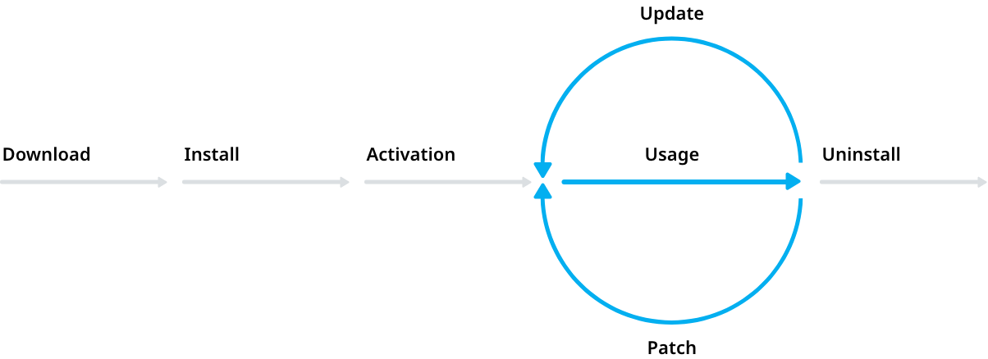

Diagram showing the typical life cycle of a product.

## Identity and Authorization management

Identity management (IdM) is the task of controlling information about users on computers. Such information includes information that authenticates the identity of a user, and information that describes information and actions they are authorized to access and/or perform.

In this sense the HUB must guarantee a user access mechanism that enables users to assume a specific digital identity, which enables access controls to be assigned and evaluated against this identity. The use of a single identity for a given user across multiple systems eases tasks for administrators and users. It simplifies access monitoring and verification and allows the organizations to minimize excessive privileges granted to one user. User access can be tracked from initiation to termination of user access.

**Features**

1. Authentication: Verification that an entity is who/what it claims to be using a password, biometrics such as a fingerprint, or distinctive behavior such as a gesture pattern on a touchscreen.
2. Authorization: Managing authorization information that defines what operations an entity can perform in the context of a specific application. For example, one user might be authorized to enter a sales order, while a different user is authorized to approve the credit request for that order.
3. Roles: Roles are groups of operations and/or other roles. Users are granted roles often related to a particular job or job function. For example, a user administrator role might be authorized to reset a user's password, while a system administrator role might have the ability to assign a user to a specific server.

## Project launcher

The Rockwell Automation products that were taken into account have the general characteristic of requiring the user to create a project within the context of that particular product.

This characteristic enables the user to have different workspaces in the same product where the work can be saved. Also the user can have other installed products, which in turn can have multiple projects too. Therefore in a single machine one user can have multiple Rockwell Automation products installed and each of these products multiple projects, forcing the user to search for a particular product launcher and then selecting the project from a list, where each product has it own UI. This flow generate a disjoint UX to the user, hence to overcome this problem, the HUB provides a centralized and unified UX where the user can launch a project without searching a launcher and within the same UI.

**Features**

1. The users will be able to create new projects and launch existing projects from a list.
2. Any existing project could be added to the listed projects.
3. A mechanism to support cloud hosted projects (legacy for old projects).
4. The HUB will allow to remove a project from disk or from the listed projects.

## Extensions life cycle

Extensions refer to software products that are complementary and works on top of other base software products. Two groups of extensions exists in the context of the studied Rockwell Automation products, the first group consists of binaries or executable code that is plugged into the base software product and used from within it. Meanwhile the second group is composed of libraries of code that can be used in the context of a project.

Given the intrinsically related nature of the extensions and the base products the HUB must provide some means in integrating the management of the life cycle of the extensions with the life cycle of the base products.

**Features**

1. A marketplace where the user can purchase any extension.
   1. The shown extensions will depend on the installed products.
   2. Interactions to handle the pay process.
2. A list of extensions:
   1. Per installed product.
   2. Per project.
   3. Uninstall process.
   4. Assign an extension to a product.
   5. Assign an extension to a project.

## Digital content (learn, news)

The use of any kind of software involves a learning process when starting to use it and the consumption of related material during the use of it.

The material can be provided in many media formats, such as text documents, videos, images and others. Also the material can be consumed from different sources, web pages, mail, video streaming platforms, among others.

Having such a heterogeneity of sources and formats does not encourage the user to learn and improve his knowledge, hence his productivity in using the product does not improve as fast as it could.

**Features**

1. The HUB could provide either an embedded browser to display some content or could redirect the user to a Rockwell Automation web page which contains the resources.

# High-level architecture

We suggest to decouple the actual functionality implementation and the UI, following the concept of backend and frontend. The backend will be the program that performs the actual management of the requests generated in the frontend.

We refer the backend as the HUB service, and the frontend as the HUB UI.

The picture describes a RAIDER deploy scenario, where to run a RAIDER instance is needed System Server and an IDE client which consumes content from a System Server.

In this scenario we have the following actors:

1. Light engineering client (LEC). A computer that access RAIDER features through a web browser, via a url location.
2. Workstation: A computer that has installed both RAIDER components, the IDE client and the System Server. It works as a standalone computer.
3. Client: A client that has installed only the RAIDER IDE client. It needs to establish a connection with a System Server.
4. System Server: A computer that works as a RAIDER System Server. It does not contain any IDE Client installed.

### 

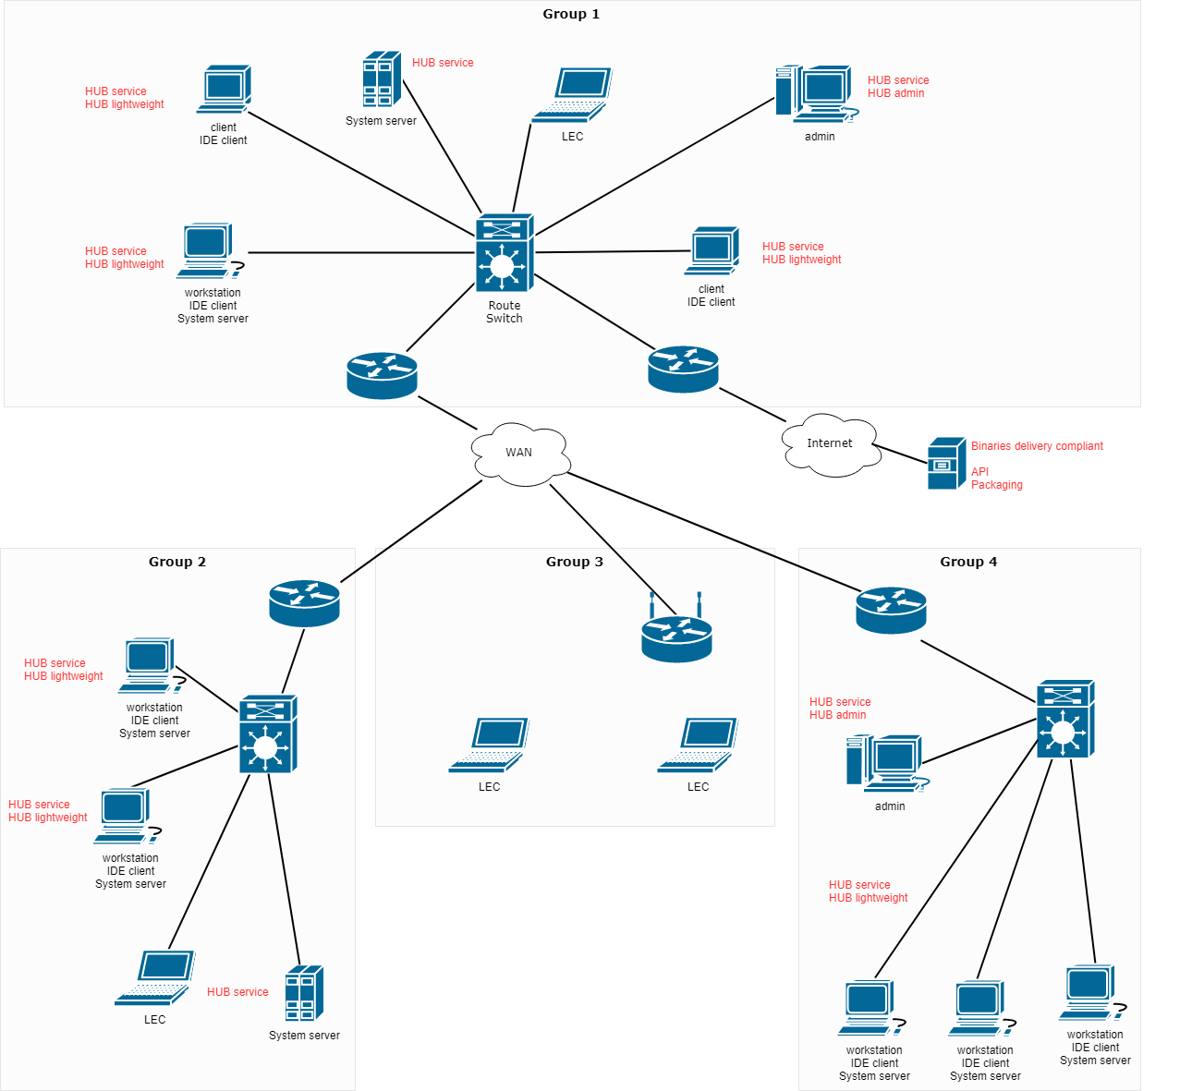

Tentative RAIDER HUB deploy diagram.

## 

## HUB service

The HUB service will be a background daemon process running on every machine that needs any kind of Rockwell Automation products. The daemon is a rest api server and client too, this enables them to work as a network of peers or friends.

**Features**

1. Will run on every machine that need Rockwell Automation software products.
2. Rest API:
   1. Communication with peers HUB service.
   2. Requests from UI.
   3. Requests from shell.
3. Obtain the binaries:
   1. Downloading using HTTP.
   2. Sharing via P2P or similar protocol.
4. Discovery process.
5. Maintain a registry of:
   1. Packages.
      1. Binaries.
   2. Projects.
   3. Extensions.

**Components**

Taking into account the scope previously defined in this document, we have designed a

system and modularize it into different components with very well defined roles, functionalities and interactions between them:

1. Package Management System.
2. Identity and Authorization System.
3. Binaries Transfer Management System.
4. Project Management system.
5. Extensions Management System.
6. Registry Management System.
7. Content Ingestion Management System.

### 

Overall architecture and interactions between components.

### Package Management System

This module is responsible for providing all the necessary means for managing the whole life cycle of Rockwell Automation products. To deliver and manage the products each software product is packaged into a software package.

A software package is an archive file containing a computer program as well as necessary metadata for its deployment. Package metadata include package description, package version, and dependencies (other packages that need to be installed beforehand).

Package managers are charged with the task of finding, installing, maintaining or uninstalling software packages upon the user's command.

Typical functions of a package management system include:

1. Working with file archivers to extract package archives
2. Ensuring the integrity and authenticity of the package by verifying their digital certificates and checksums
3. Looking up, downloading, installing or updating existing software from a software repository or app store
4. Grouping packages by function to reduce user confusion
5. Managing dependencies to ensure a package is installed with all packages it requires, thus avoiding "dependency hell"

#### Packaging

A package format is a type of archive containing computer programs and additional metadata needed by package managers. While the archive file format itself may be unchanged, package formats bear additional metadata, such as a manifest file or certain directory layouts. Packages may contain either source code or executable files.

Packages may be converted from one type to another with software such as Alien.

##### **Npm (Node** package **manager)**

A **package** is:

1. a folder containing a program described by a package.json file
2. a gzipped tarball containing (a)
3. a url that resolves to (b)
4. a <name>@<version> that is published on the registry with (c)
5. a <name>@<tag> that points to (d)
6. a <name> that has a "latest" tag satisfying (e)
7. a git url that, when cloned, results in (a).

Even if you never publish your package, you can still get a lot of benefits of using npm if you just want to write a node program (a), and perhaps if you also want to be able to easily install it elsewhere after packing it up into a tarball (b).

**Package.json**

You need to have a package.json file in the root of your project to do much of anything with npm. That is basically the whole interface.

At the very least, you need:

1. name: This should be a string that identifies your project. Please do not use the name to specify that it runs on node, or is in JavaScript. You can use the "engines" field to explicitly state the versions of node (or whatever else) that your program requires, and it's pretty well assumed that it's JavaScript.  
   It does not necessarily need to match your GitHub repository name.  
   So, node-foo and bar-js are bad names. foo or bar are better.
2. version: A semver-compatible version.
3. engines: Specify the versions of node (or whatever else) that your program runs on. The node API changes a lot, and there may be bugs or new functionality that you depend on. Be explicit.
4. author: Take some credit.
5. scripts: If you have a special compilation or installation script, then you should put it in the scripts object. You should definitely have at least a basic smoke-test command as the "scripts.test" field.
6. main: If you have a single module that serves as the entry point to your program (like what the "foo" package gives you at require("foo")), then you need to specify that in the "main" field.
7. directories: This is an object mapping names to folders. The best ones to include are "lib" and "doc", but if you use "man" to specify a folder full of man pages, they'll get installed just like these ones.

**Registry**

To resolve packages by name and version, npm talks to a registry website that implements the CommonJS Package Registry specification for reading package info.

npm is configured to use npm, Inc.'s public registry at https://registry.npmjs.org by default. Use of the npm public registry is subject to terms of use available at https://www.npmjs.com/policies/terms.

The npm public registry is powered by a CouchDB database, of which there is a public mirror at https://skimdb.npmjs.com/registry. The code for the couchapp is available at https://github.com/npm/npm-registry-couchapp.

**References:**

1. <https://www.npmjs.com/>

**Versioning**

Software upgrade versioning is the process of assigning either unique version names or unique version numbers to unique states of computer software. Within a given version number category (major, minor), these numbers are generally assigned in increasing order and correspond to new developments in the software. At a fine-grained level, revision control is often used for keeping track of incrementally different versions of information, whether or not this information is computer software.

**Semver - The Semantic versioner for npm**

Given a version number MAJOR.MINOR.PATCH, increment the:

1. MAJOR version when you make incompatible API changes,
2. MINOR version when you add functionality in a backwards compatible manner, and
3. PATCH version when you make backwards compatible bug fixes.

Additional labels for pre-release and build metadata are available as extensions to the MAJOR.MINOR.PATCH format.

|  |
| --- |
| const semver = require('semver')  semver.valid('1.2.3') // '1.2.3'  semver.valid('a.b.c') // null  semver.clean(' =v1.2.3 ') // '1.2.3'  semver.satisfies('1.2.3', '1.x || >=2.5.0 || 5.0.0 - 7.2.3') // true  semver.gt('1.2.3', '9.8.7') // false  semver.lt('1.2.3', '9.8.7') // true  semver.minVersion('>=1.0.0') // '1.0.0'  semver.valid(semver.coerce('v2')) // '2.0.0'  semver.valid(semver.coerce('42.6.7.9.3-alpha')) // '42.6.7' |

##### 

**References:**

1. [https://semver.org](https://semver.org/)

##### Microsoft install technologies

|  |  |  |
| --- | --- | --- |
| Tech | Advantages | Disadvantages |
| MSI | * Simple, possible unattended. * Basic GUI that install or uninstall the program. * No extras or options. * Is a compressed set of installer files containing all necessary data for the software. | * The install process won’t detect if the software already exists or if any components are missing. * Overwrite any files in the install path. |
| EXE | * Can include options for languages, add-ons, detecting previous installations, and more. * Custom install paths and choosing which components to install. * Can add own branding to the GUI and incorporate language-specific terms of service. | * Makes a silent unattended install much more difficult, and thus less useful in an enterprise situation. |
| APPX | * Share benefits of MSI installers. * Simple, straight forward installers with few choices given to the end user. * Allows for an easier upgrade path from older versions to new. * Allows for a cleaner uninstall. * Rely on container technology, so they are isolated from the rest of the OS for security. | * Only for Universal Windows Apps. * MSI or EXE must be rewritten. * Only Windows 10. |
| MSIX | * Benefits of APPx while similar to MSI file. * Is a straight forward installer that system administrator can even script for automatic, “unattended” installation. * Relies on container technologies. * Install like an MSI file, but behind the scenes, it install like an APPx file. * MSIX distribution outside the Microsoft Store is possible. * Is easy to repackage older program to MSIX. * Support for cross-platform compatibility.   + Released an SDK to enhance cross-platform compatibility. * Uninstall more cleany:   + When you install a program using MSI and EXE, that program can make registry changes and create files and folders throughout your system.   + When you uninstall the program, these files and registry keys often get left behind, leaving clutter on your system.   + With MSIX, programs are installed in a container and all their necessary files either stay within that container or follow precise, predictable rules about where those files may live (such as living in AppData).   + When you uninstall all the data goes with the program, no clutter behind. |  |

**References:**

1. <https://www.advancedinstaller.com/msix-support-windows.html>
2. <https://www.advancedinstaller.com/msix-introduction.html>
3. <https://www.howtogeek.com/402021/the-future-of-software-on-windows-what-is-an-msix-file/>

##### Proprietary install technologies

|  |  |  |
| --- | --- | --- |
| Technology | Features | Known issues |
| Flexera Installshield | * Build clean installs, upgrades and uninstalls for windows incredible quickly and easily. * Simplify virtual and cloud-based deployments. * Easily create a native MSIX package or convert any MSI file into MSIX. * Deliver a seamless customer UX. * Standard for windows installer (MSI) and InstallScript installations. * Build installation suited to install multiple products for windows, MSIX and more. |  |
| NSIS | * Free. * Easy to learn. * Documented. * Lot of examples. | * Difficult to try things out of the box:   + Lean how to write code in NSIS-> Awful macro language.   + Write extension DLLs. * No built-in functionality to kill process in NSIS. * Dependencies check hard to implement |

**References:**

1. FLEXERA:<https://blog.flexerasoftware.com/software-installation/?_ga=2.106209027.1232543975.1561984515-249249859.1561984515>
2. NSIS:

<https://nsis.sourceforge.io/Simple_tutorials>

1. Custom installers: <https://blog.kowalczyk.info/article/8nqb/writing-a-custom-installer-for-windows-software.html>

##### Unattended installation

An unattended installation is the traditional method of deploying a Windows operating system. Unattended installations use an **answer file** named Unattend.[xml](https://www.sciencedirect.com/topics/computer-science/xml), which **contains user input** to various GUI dialog boxes that appear during the installation process. Unattended installation is the most practical way to install Windows Vista when the [client computers](https://www.sciencedirect.com/topics/computer-science/client-computer) have different hardware components. Unattended installations save deployment time and can be used either for clean installs or in place upgrades.

#### Industry state

##### Unity

Unity Hub provides a lean UI where all installed engines are listed. Here the user can add a new version of the engine, locate a previously installed engine and uninstall any installed engine.

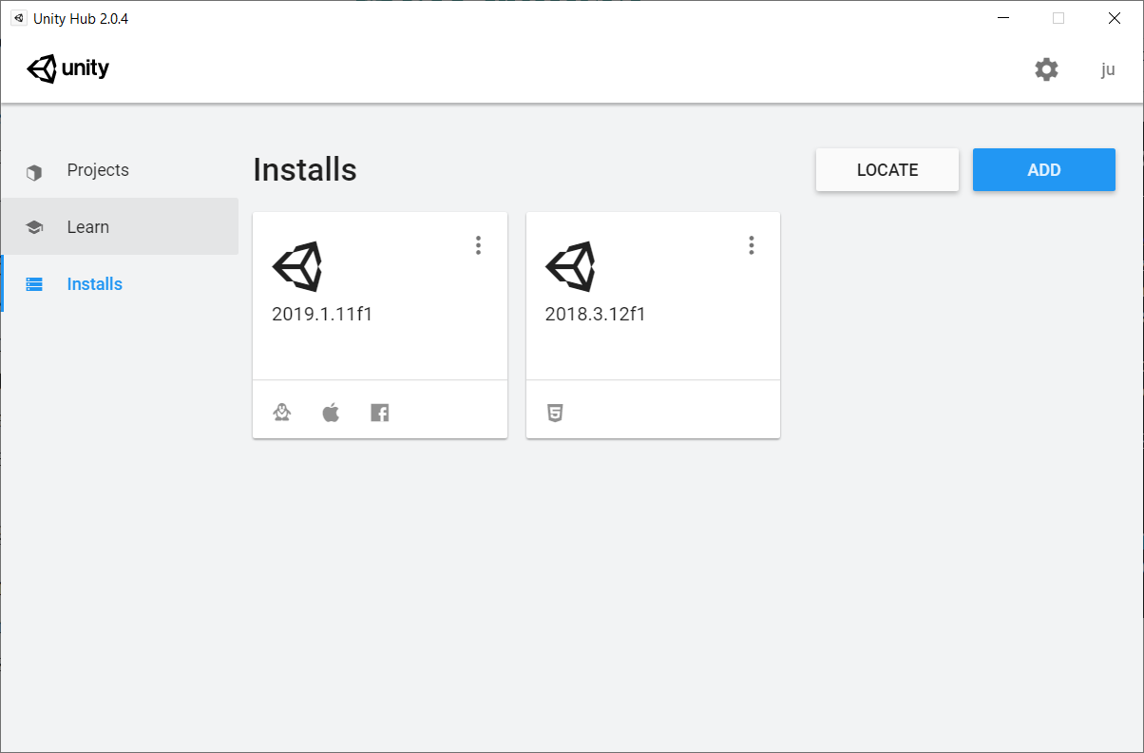

Install section in Unity Hub. All installed engines are listed.

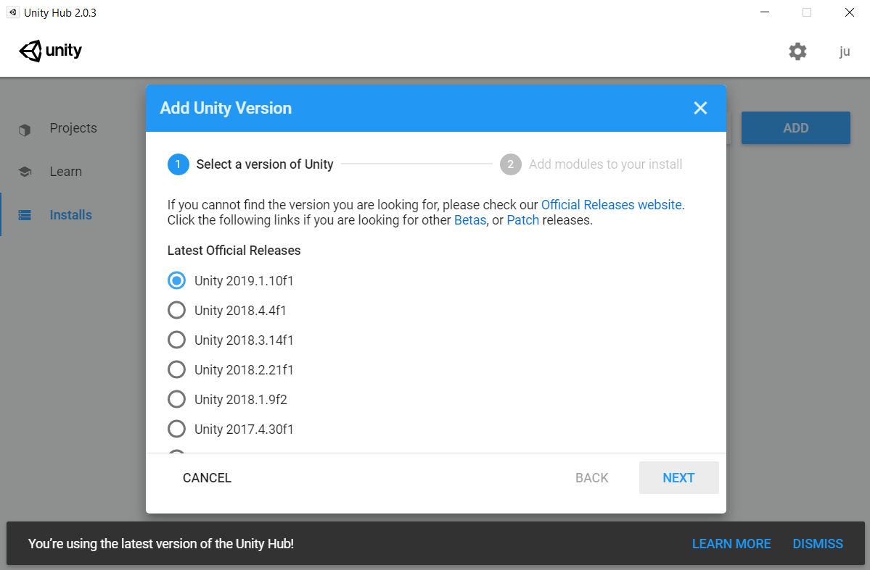

Install section in Unity Hub. List of available versions to install.

##### CryEngine

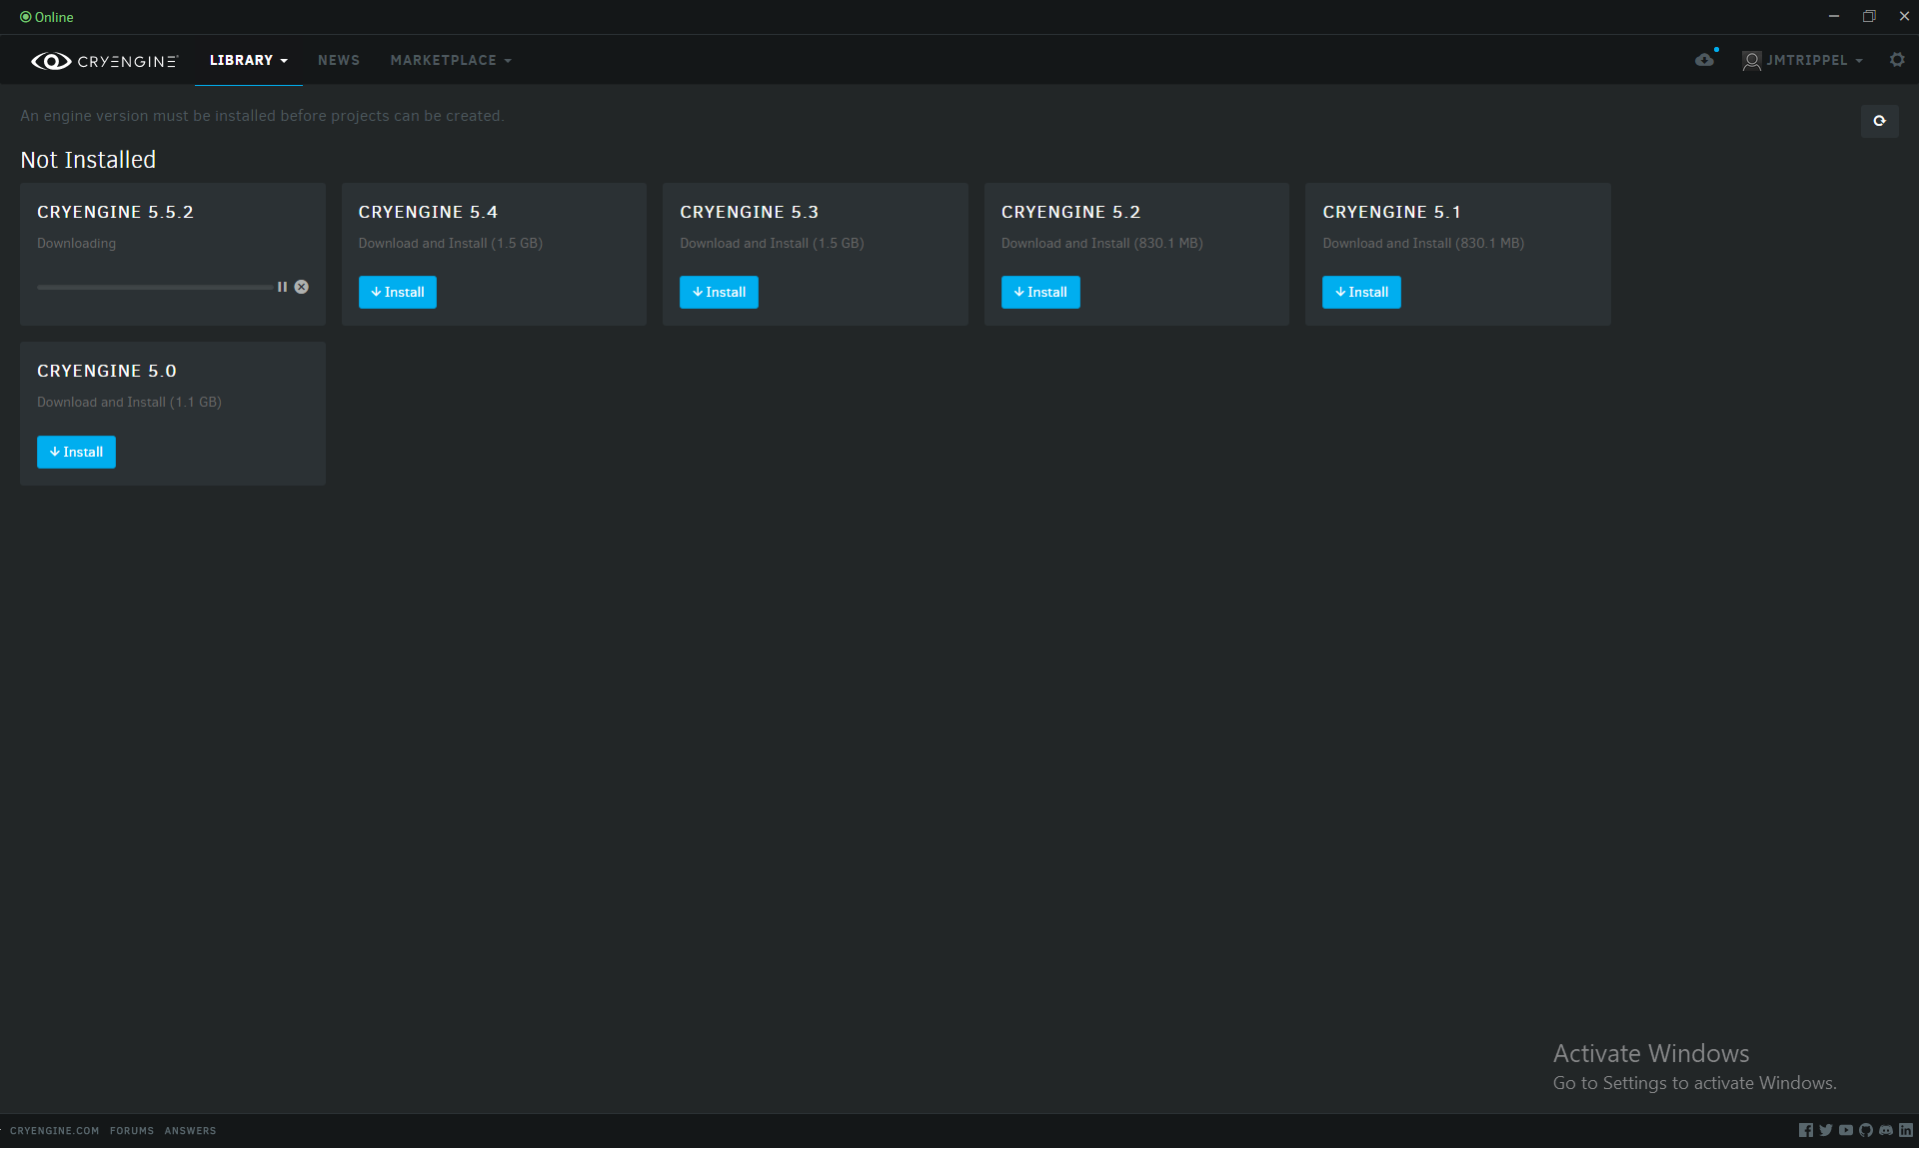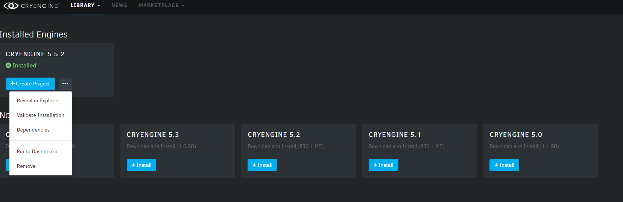

Library section in CryEngine.

Top) List of available versions to install.Bottom) Installed Engines and available to install engines are listed.

##### Epic Games

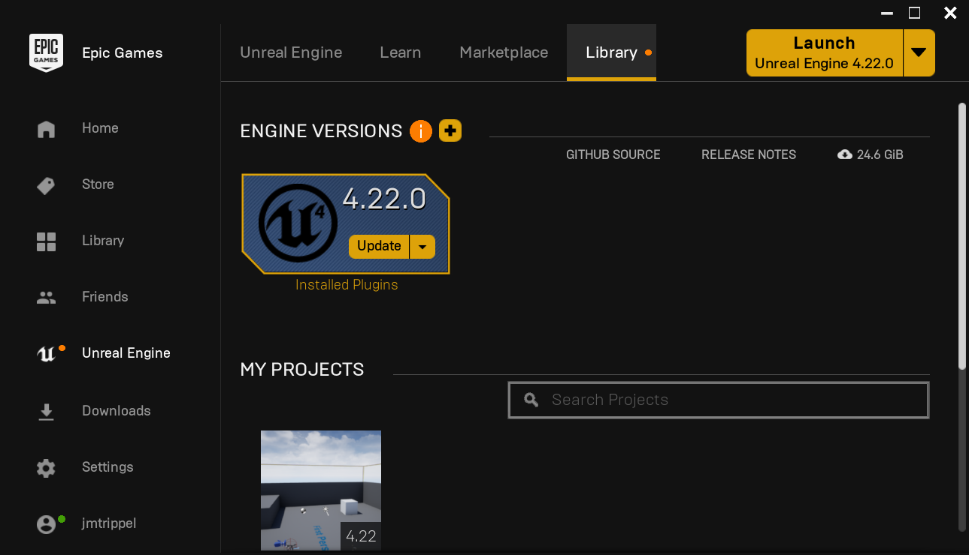

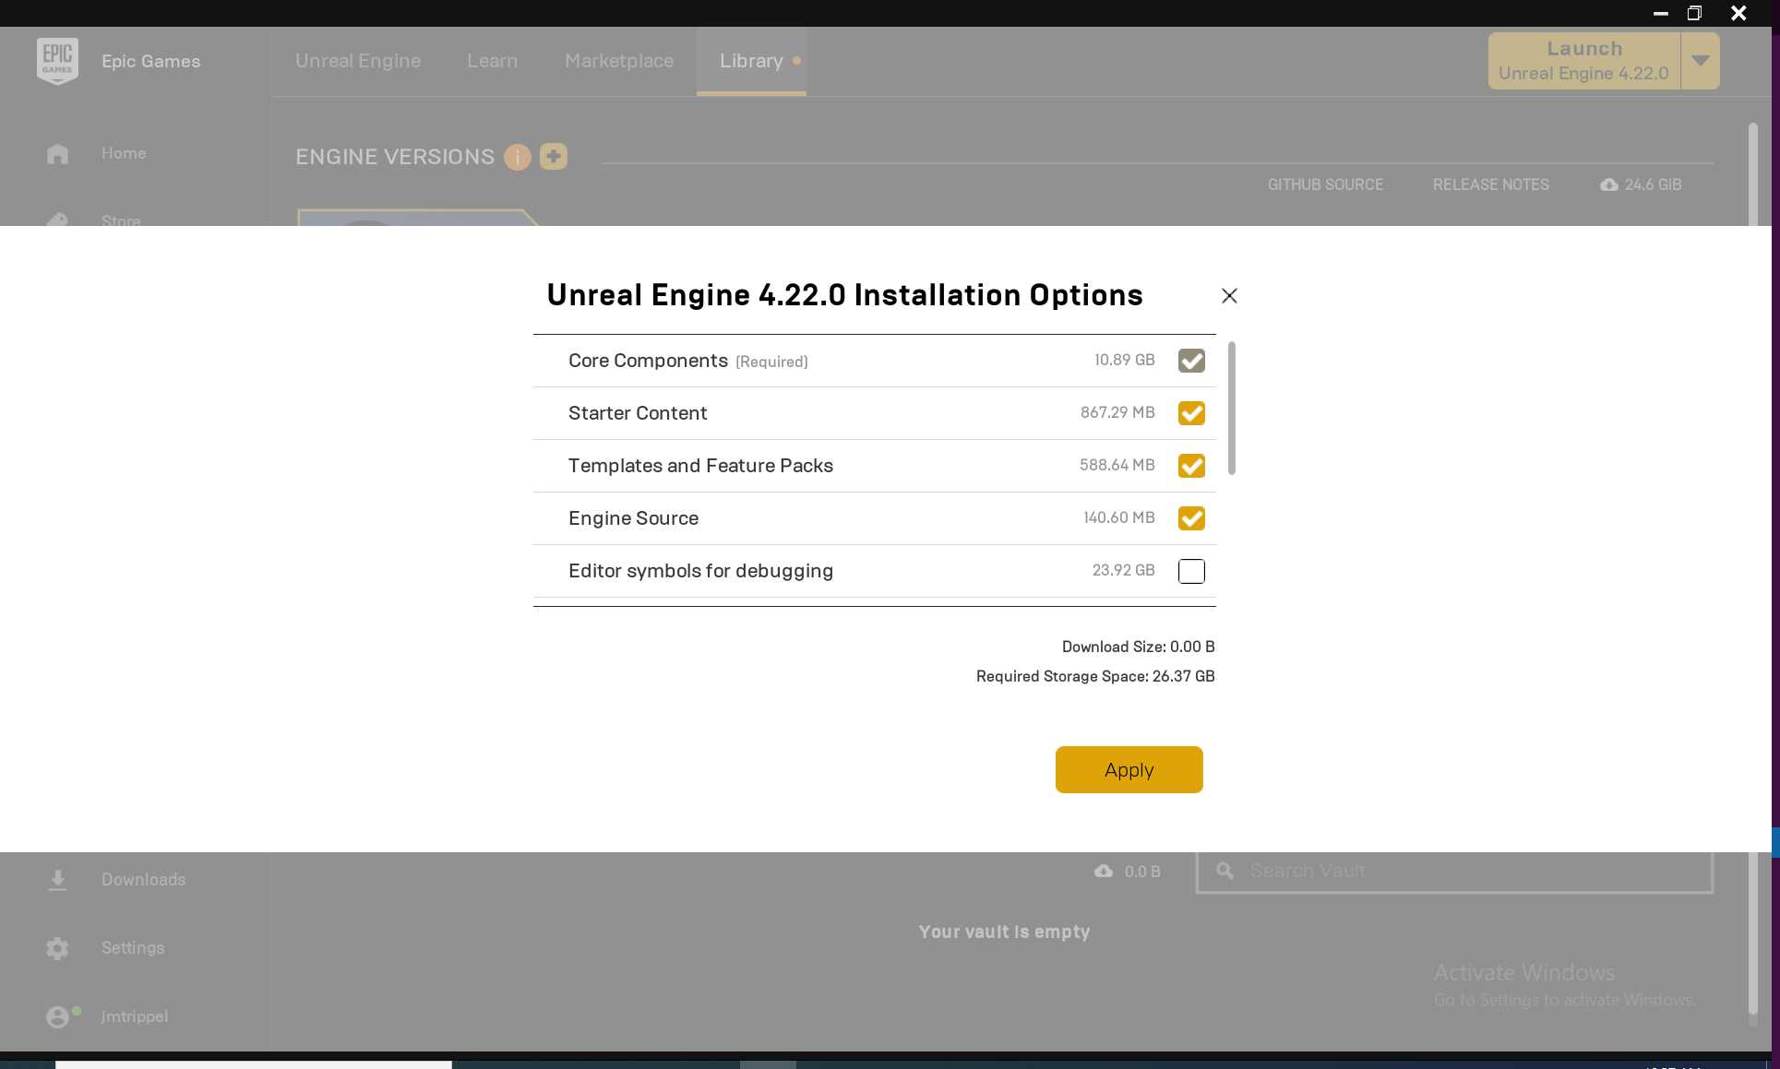

Library section in Epic Launcher.

Top) List of installed versions of the engine.Bottom) Install modal with component selection.

### Identity and Authorization Management System

This module is responsible for handling the Authentication of any of the digital identities that exists within Rockwell Automation ecosystem. For authenticate an identity the system must use an authentication method that guarantee that a user is who he claims to be.

Nowadays, multiple types of mechanisms exist, each providing some advantages depending on the context.

#### Types of authentication methods

Traditional authentication depends on the use of a password file, in which user IDs are stored together with hashes of the passwords associated with each user. When logging in, the password submitted by the user is hashed and compared to the value in the password file. If the two hashes match, the user is authenticated.

**Two-factor authentication**

Two-factor authentication adds an extra layer of protection to the process of authentication. 2FA requires that a user provide a second authentication factor in addition to the password. 2FA systems often require the user to enter a verification code received via text message on a preregistered mobile phone, or a code generated by an authentication application.

**Multi Factor authentication**

Multi Factor authentication requires users to authenticate with more than one authentication factor, including a biometric factor like fingerprint or facial recognition, a possession factor like a security key fob or a token generated by an authenticator app.

**One-time password**

A one-time password is an automatically generated numeric or alphanumeric string of characters that authenticates a user. This password is only valid for one login session or transaction, and is usually used for new users, or for users who lost their passwords and are given a one-time password to log in and change to a new password.

**Three-factor authentication**

Three-factor authentication (3FA) is a type of MFA that uses three authentication factors, usually a knowledge factor (password) combined with a possession factor (security token) and inherence factor (biometric).

**Mobile authentication**

Mobile authentication is the process of verifying user via their devices or verifying the devices themselves. This lets users log into secure locations and resources from anywhere. The mobile authentication process involves multifactor authentication that can include one-time passwords, biometric authentication or QR code validation.

**Continuous authentication**

With continuous authentication, instead of a user being either logged in or out, a company's application continually computes an "authentication score" that measures how sure it is that the account owner is the individual who's using the device.

**API authentication**

The standard methods of managing API authentication are: HTTP basic authentication; API keys and OAuth.

* **In HTTP basic authentication**: the server requests authentication information, i.e., a username and password, from a client. The client then passes the authentication information to the server in an authorization header.
* **In the API key authentication method:** a first-time user is assigned a unique generated value that indicates that the user is known. Then each time the user tries to enter the system again, his unique key is used to verify that he is the same user who entered the system previously.
* **Open Authorization (OAuth):** is an open standard for token-based authentication and authorization on the internet. OAuth allows a user's account information to be used by third-party services, such as Facebook, without exposing the user's password. OAuth acts as an intermediary on behalf of the user, providing the service with an access token that authorizes specific account information to be shared.

##### 

#### Industry state

##### Unity

Unity ID is your user account with Unity. It allows you to connect with your Unity teams and resources, and securely control access to Unity services for you and your team members.

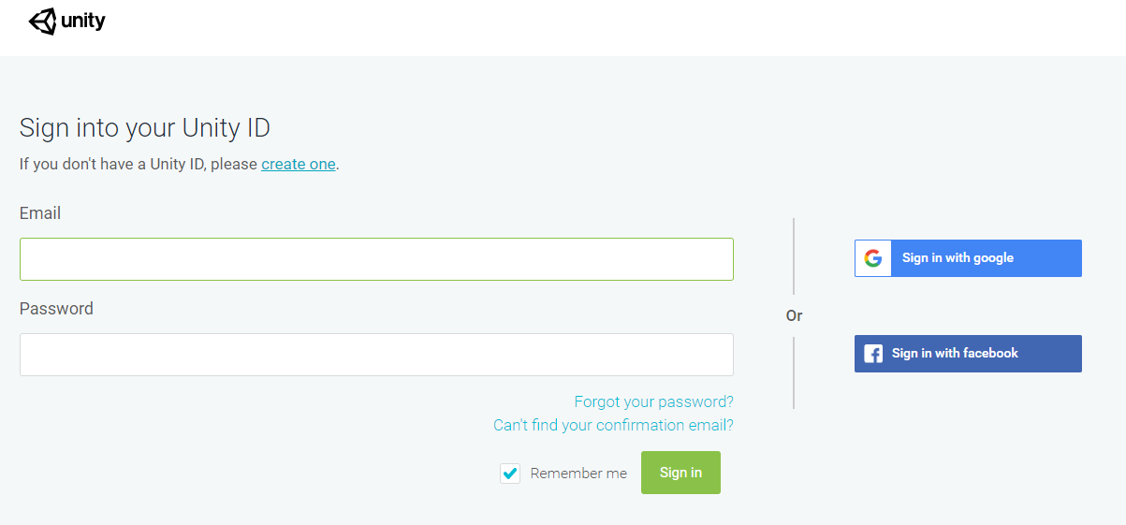

Unity login view.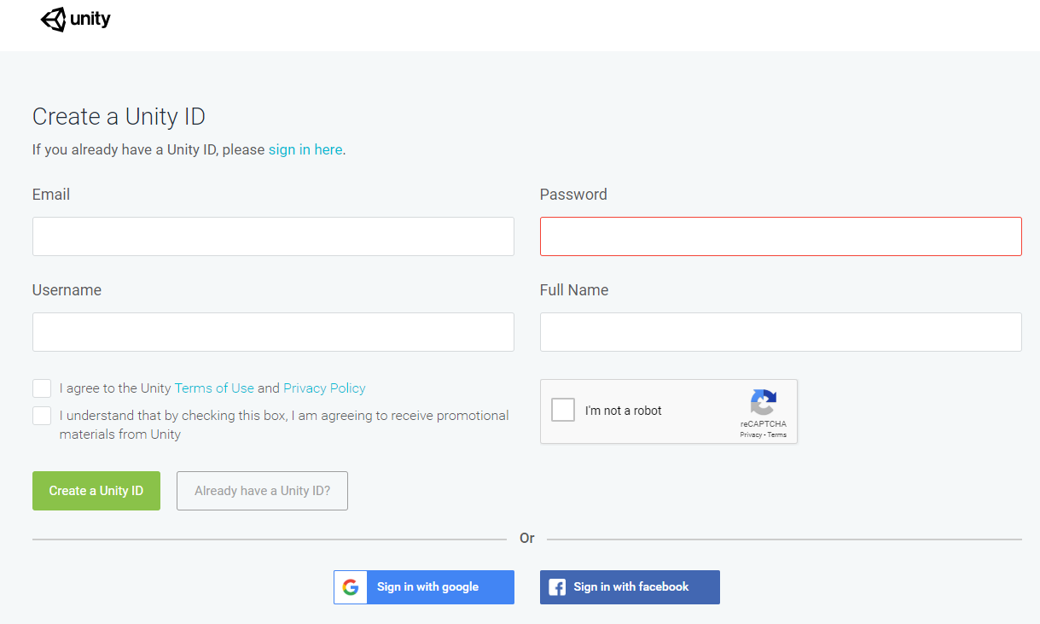

Unity new user creation view.

Unity source code is not public, cannot be accessed by third parties, therefore only serves as a reference for the UX.

###### 

##### Epic Games

Epic Games also provides a similar UX for the authentication and the creation of a user.

|  |  |
| --- | --- |
|  |  |

Epic Games Launcher.

You can see on the left) the login view and on the right) the new user creation view.

Even though Unreal Engine code is public the Launcher source code is not, the UX is useful as a template.

##### 

##### CryEngine

As is shown below CryEngine also provides a similar authentication management page.

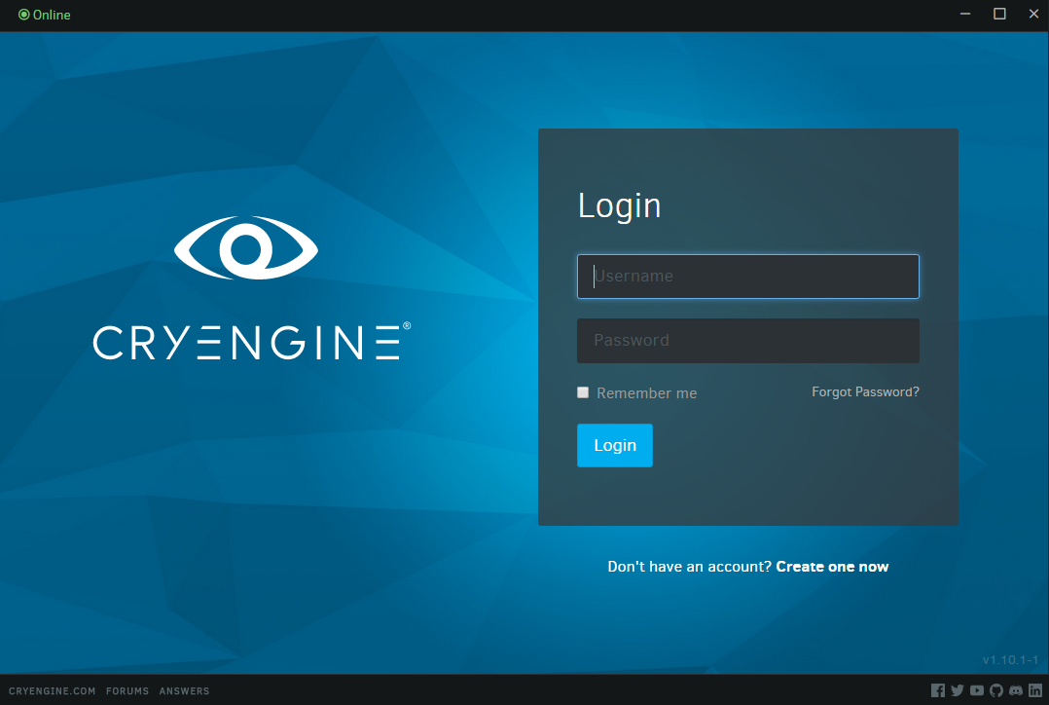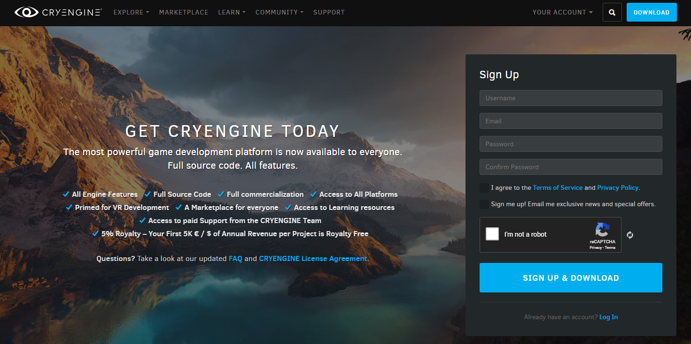

CryEngine Authentication Flows.

Top) Login screen. Bottom) New user creation screen.

In this case, the entire source code of the engine and the launcher is available for public access.

**References:**

1. User registration web portal: <https://www.cryengine.com/user/registration>
2. Source code:
   1. GitHub: <https://github.com/CRYTEK/CRYENGINE>
   2. In particular the login manager class handle the Login process: <https://github.com/CRYTEK/CRYENGINE/blob/3ea599c619a30ee406dc3c9fd02a3427b597279c/Code/GameSDK/GameDll/Network/LoginManager/LoginManager.cpp>

### Binaries Transfer Management

This module handles the acquisition and sharing of binaries from external sources (PCDC, lan, media devices).

Some of the minimum features that this module must include are:

1. Perform binaries transfer operations:
   1. Download binaries from remote repository as PCDC.
   2. Download binaries from a lan caching schema.
   3. Import/Export binaries from media.
2. Handle connection issues:
   1. Seamless streaming.

One of the main issues that arise when is needed to consume content over a network is how to get those content. Multiple options are available for handling the download, each one offering different advantages and disadvantages depending on the context:

1. Client-Server.
2. P2P.
3. F2F.
4. Media devices.

#### Client-server

The client-server characteristic describes the relationship of cooperating programs in an application. The server component provides a function or service to one or many clients, which initiate requests for such services. Servers are classified by the services they provide. For example, a web server serves web pages and a file server serves computer files. A shared resource may be any of the server computer's software and electronic components, from programs and data to processors and storage devices. The sharing of resources of a server constitutes a service.

Whether a computer is a client, a server, or both, is determined by the nature of the application that requires the service functions. For example, a single computer can run web server and file server software at the same time to serve different data to clients making different kinds of requests. Client software can also communicate with server software within the same computer.Communication between servers, such as to synchronize data, is sometimes called inter-server or server-to-server communication.

Clients and servers exchange messages in a request–response messaging pattern. The client sends a request, and the server returns a response. This exchange of messages is an example of inter-process communication. To communicate, the computers must have a common language, and they must follow rules so that both the client and the server know what to expect. The language and rules of communication are defined in a communications protocol. All client-server protocols operate in the application layer.

##### 

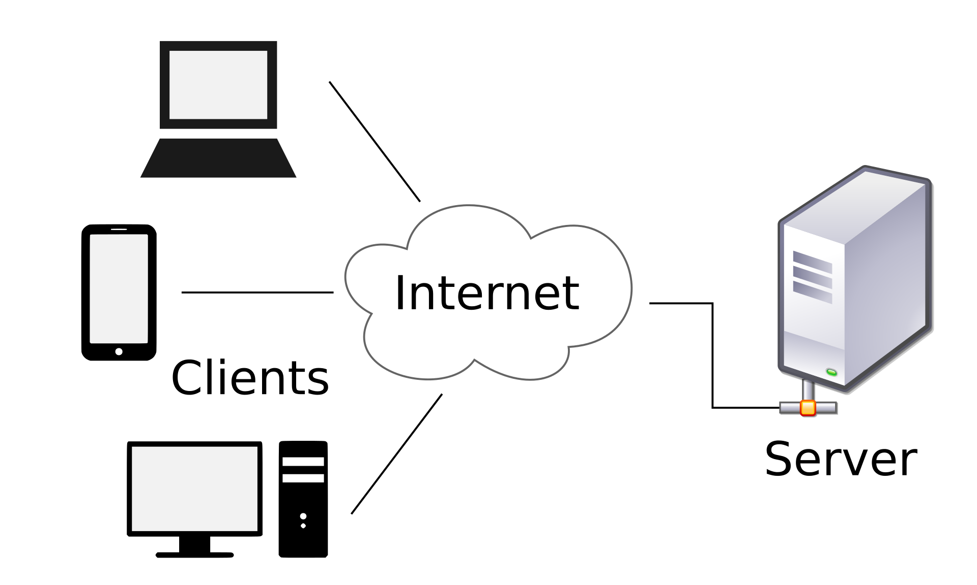

An example of Client-Server architecture.

#### P2P

Peer-to-peer (P2P) computing or networking is a distributed application architecture that partitions tasks or workloads between peers. Peers are equally privileged, equipotent participants in the application. They are said to form a peer-to-peer network of nodes.

Peers make a portion of their resources, such as processing power, disk storage or network bandwidth, directly available to other network participants, without the need for central coordination by servers or stable hosts. Peers are both suppliers and consumers of resources, in contrast to the traditional client-server model in which the consumption and supply of resources is divided. Emerging collaborative P2P systems are going beyond the era of peers doing similar things while sharing resources, and are looking for diverse peers that can bring in unique resources and capabilities to a virtual community thereby empowering it to engage in greater tasks beyond those that can be accomplished by individual peers, yet that are beneficial to all the peers.

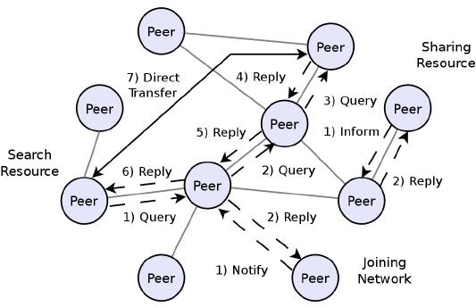

An example of P2P architecture.

#### Friend to Friend protocol (F2F)

Unlike other kinds of private P2P, users in a friend-to-friend network cannot find out who else is participating beyond their own circle of friends, so F2F networks can grow in size without compromising their users' anonymity. Retroshare, WASTE, GNUnet, Freenet and OneSwarm are examples of software that can be used to build F2F networks, though RetroShare is the only one of these configured for friend-to-friend operation by default.

**References:**

1. <https://pdos.csail.mit.edu/~jinyang/pub/iptps-f2f.pdf>
2. <http://turtle-p2p.sourceforge.net/turtleinitial.pdf>

#### Akamai content delivery

Akamai delivers web content over its Intelligent Platform by transparently mirroring elements such as HTML, CSS, software downloads, and media objects from customers' servers. The Akamai server is automatically picked depending on the type of content and the user's network location. Receiving content from an Akamai server close to the user allows for faster download times and less vulnerability to network congestion. Akamai claims to provide better scalability by delivering the content over the last-mile from servers close to end-users, avoiding the middle-mile bottleneck of the Internet. The Download Delivery product line includes HTTP downloads for large downloadable objects, a customizable application for consumers, and analytics tools with metrics that monitor and report on the download process.

#### Industry state

##### Blizzard’s Battle.net Download Manager UI

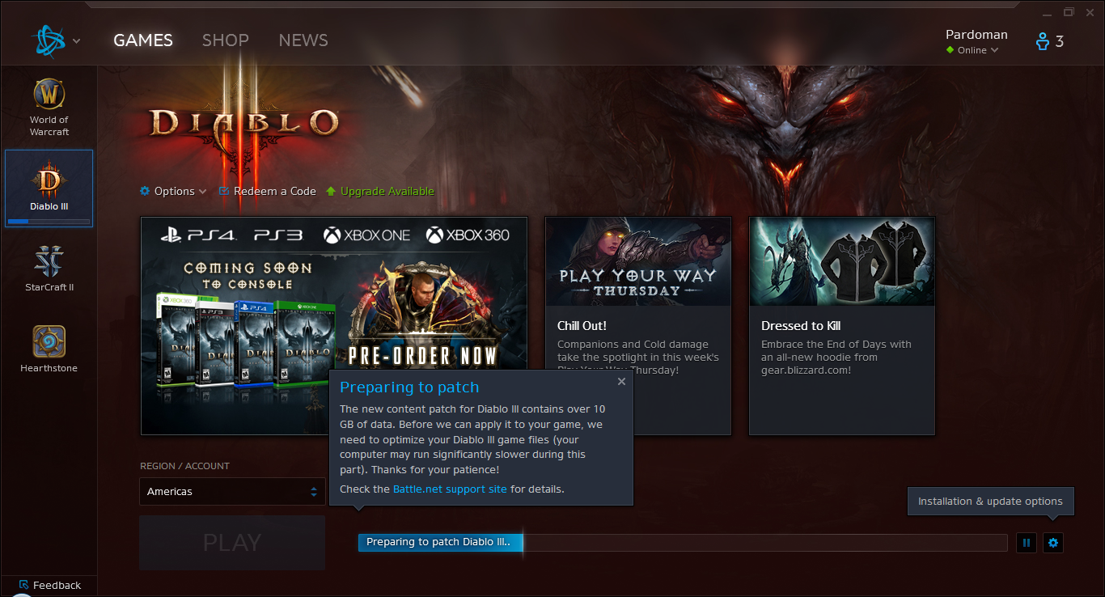

Main Screen with game selected. Notice the progress bar indicating installation process.

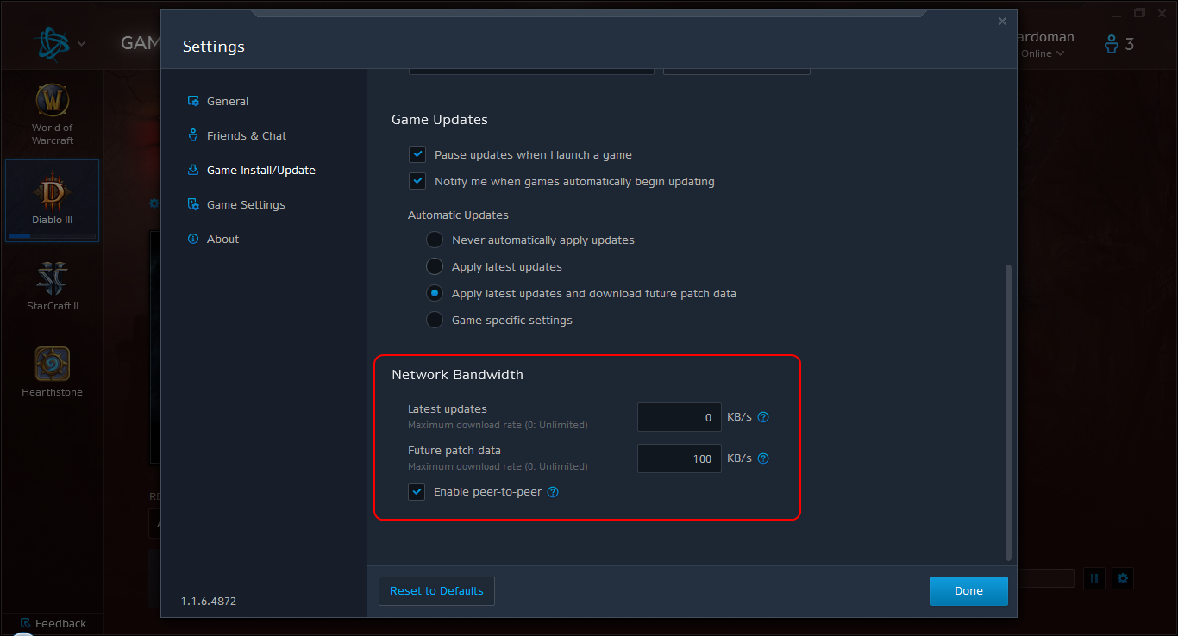

P2P options available to the player circled in red. Notice that options here are very few, compared to other feature rich P2P torrent apps.

**Tech stack**

As a reference, some of the technologies used by Blizzard’s Download Manager (see their About section) are:

1. [c-ares](http://c-ares.haxx.se/): C library for asynchronous DNS requests (including name resolving).
2. [Chromium Embedded Framework (CEF)](https://code.google.com/p/chromiumembedded/): is a simple framework for embedding Chromium-based browsers in other applications.
3. [CURL](http://curl.haxx.se/): Command line tool for transferring data with URL syntax.
4. [Protocol Buffers](https://code.google.com/p/protobuf/): Encoding structured data in an efficient yet extensible format.
5. [PCRE](http://www.pcre.org/): Perl Compatible Regular Expressions lib.
6. [Qt](http://qt-project.org/): Cross-platform application and UI framework for developers using C++.

**Description**

The solution consists of implementing a download architecture on top of the BitTorrent and HTTP protocols that allows client/server and peer-to-peer (P2P) downloading of files.

Under P2P protocols not only do clients download files from a server or “seed”, but also, from one another, increasing the download data rate perceived by the user while allowing the service to scale with reduced costs for the content host.

The P2P implementation is to be based on the open source libtorrent library, a robust, proven library that is distributed under a BSD license. This license allows using it without having to distribute the application’s source code to users of the application.

**Download Workflow**

In order to serve files through BitTorrent, the following requirements will have to be met:

1. Host a BitTorrent tracker. The tracker can be developed in-house or an open source solution can be used.
2. Run a “seed” or a “seedbox” - one or more peers that already have a complete copy of the content and will be used for bootstrapping and helping file distribution.
   1. Rockwell can run as many seeds as necessary to meet network demands. Additional seeds can be dynamically added to help high-congestion situations.
   2. Webseeds (regular HTTP servers) can also be added to bootstrap the peer-to-peer network.
3. Run a server-side service that allows the user to log using her Rockwell digital account.
4. Once logged in, the user’s entitlements are checked, and a MetaInfo file (.torrent) is downloaded. The MetaInfo file contains a description of the packages to be downloaded, their checksums and the tracker.
   1. Note: the MetaInfo file could also be embedded as part of an entitlements file.
5. Using the MetaInfo file, the DownloadManager starts the peer-to-peer download process of the content.

File fragments (“pieces”) that comprise the content will be downloaded from peer nodes until a full copy of the original file is complete.

Additionally, BitTorrent protocol transfers could be complemented with an optional client/server downloads over HTTP. This mechanism would be triggered either manually or under specific network conditions to help transfer files faster.

HTTP download support will require a simpler configuration on Rockwell’s side:

1. Host the Product installer in a HTTP(S) file server.
2. The Download Manager determines if it will perform an HTTP download instead of a BitTorrent one if no .torrent into is provided in the meta-information or if the peer-to-peer network is not providing enough bandwidth.
3. Files are transferred in the regular client/server fashion. Since this method will be implemented over the web seeding bittorrent’s feature, multiple HTTP servers can be added to speed up the download speed since clients can do concurrent downloads for the same content from different web seeds.

Because of its design, the BitTorrent protocol allows scaling the number of simultaneous downloads with only a modest increase in load when compared to other protocols such as HTTP. Nonetheless, under specific conditions it may be desirable to switch from BitTorrent to a client/server transfer. The Download Manager will support this scenario, with certain restrictions. Both download methods must be fault tolerant in case of power off, network problems or crash picking up where they left off.

**Content Ingestion / Wrapping Tool**

Serving content over the BitTorrent protocol requires the said content to be prepared for distribution. Once the content has been packaged, each individual download unit it will have to be prepared by running a utility that generates the MetaInfo file for that file.

The following Proof-of-Concept source code presents an example of a MetaInfo creation program:

|  |
| --- |
| #include <iostream>  #include <fstream>  #include <iterator>  #define BOOST_ASIO_SEPARATE_COMPILATION  #include <libtorrent/entry.hpp>  #include <libtorrent/bencode.hpp>  #include <libtorrent/torrent_info.hpp>  #include <libtorrent/file.hpp>  #include <libtorrent/storage.hpp>  #include <libtorrent/hasher.hpp>  #include <libtorrent/create_torrent.hpp>  #include <libtorrent/file_pool.hpp>  #include <boost/filesystem/operations.hpp>  #include <boost/filesystem/path.hpp>  #include <boost/filesystem/fstream.hpp>  #include <boost/bind.hpp>  bool file_filter(const boost::filesystem::path& filename)  {  return true;  }  void print_progress(int i, int num)  {  std::cerr << "\r" << (i + 1) << "/" << num;  }  int main(int argc, char* argv[])  {  using namespace libtorrent;  using namespace boost::filesystem;  if (argc != 4 && argc != 5)  {  std::cerr << "usage: make_torrent <output torrent-file> <announce url> <file or dir> [url-seed]\n";  return -1;  }  #ifndef BOOST_NO_EXCEPTIONS  try{  #endif  file_storage fs;  file_pool fp;  path full_path = complete(path(argv[3]));  add_files(fs, full_path.string(), file_filter);  const int piece_size = 256 * 1024;  create_torrent t(fs, piece_size);  t.add_tracker(argv[2]);  set_piece_hashes(t, full_path.branch_path().string(), boost::bind(&print_progress, _1, t.num_pieces()));  std::cerr << std::endl;  if (argc == 5)  {  t.add_url_seed(argv[4]);  }  ofstream out(complete(path(argv[1])), std::ios_base::binary);  bencode(std::ostream_iterator<char>(out), t.generate());  #ifndef BOOST_NO_EXCEPTIONS  } catch (std::exception& ex) {  std::cerr << ex.what() << std::endl;  return -2;  }  #endif  return 0;  } |
| Sample MetaInfo generation program. Based on libtorrent and Boost. |

**Implementation Example**

This implementation example demonstrates how easily libtorrent can be used to create peer-to-peer clients. Although the final implementation will be done in the C++ programming language, this short python script depicts the basic concepts behind the library using a simpler to understand syntax.

This script opens a BitTorrent MetaInfo file, parses it and downloads the parts described by it until the client becomes a seed itself, meaning the content download is complete.

|  |
| --- |
| import libtorrent as lt  import time  ses = lt.session()  ses.listen_on(6881, 6891)  e = lt.bdecode(open("test.torrent", 'rb').read())  info = lt.torrent_info(e)  params = { save_path: './', \  storage_mode: lt.storage_mode_t.storage_mode_sparse, \  ti: info }  h = ses.add_torrent(params)  while not h.is_seed():  s = h.status()  state_str = ['queued', 'checking', 'downloading metadata',\  'downloading', 'finished', 'seeding', 'allocating']  print '%.2f%% complete \  (down: %.1f kb/s up: %.1f kB/s peers: %d) %s' % \  (s.progress * 100, s.download_rate / 1000, s.upload_rate / 1000, s.num_peers, state_str[s.state])  time.sleep(1) |
| http://www.rasterbar.com/products/libtorrent/python_binding.html |

**Protocol switching between P2P and Direct Download**

Although BitTorrent networks by design offer an architecture theoretically more scalable than client/server connections, it is desirable to provide an alternative client/server download mechanism. Client/server is a proven architecture that can be trusted to work in case users encounter issues while using BitTorrent.

When content is to be downloaded, a protocol will be selected either by the user or specified by Rockwell via meta-information. This selected protocol will be the preferred one, but in case of failure (not enough bandwidth, server down, etc), DownloadManager will switch over the other protocol.

**Performance and scalability assessment**

By leveraging a P2P architecture, because every client acts as a server as well, system scalability is not an issue. This means that, as more people simultaneously download a given file, the faster it can be potentially downloaded.

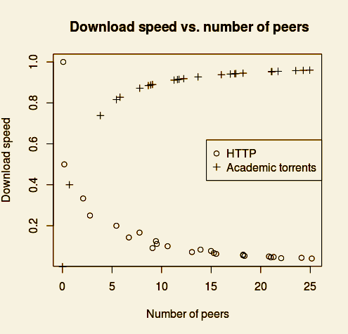

The following image depicts this concept applied to the field of downloadic academic articles.

Compared to HTTP, the BitTorrent protocol has the additional advantage of not having any single point of failure. This is because, as long as all the parts of the content being downloaded are in the network, even if no peer has the complete file, the content will still be able to be assembled by all.

##### LanHunt

LanHunt is a lan based search engine, which enables users to download and look for content shared on local area network. LanHunt is fast, typically giving results in seconds. Database update is required only once from the inbuilt updater. Supports parallel downloads, parallel searching, direct "open location" feature, filetype based narrowing and much more.

**References:**

1. <https://sourceforge.net/projects/lanhunt/files/>
2. <https://github.com/sanjay51/Lanhunt>

##### Unity

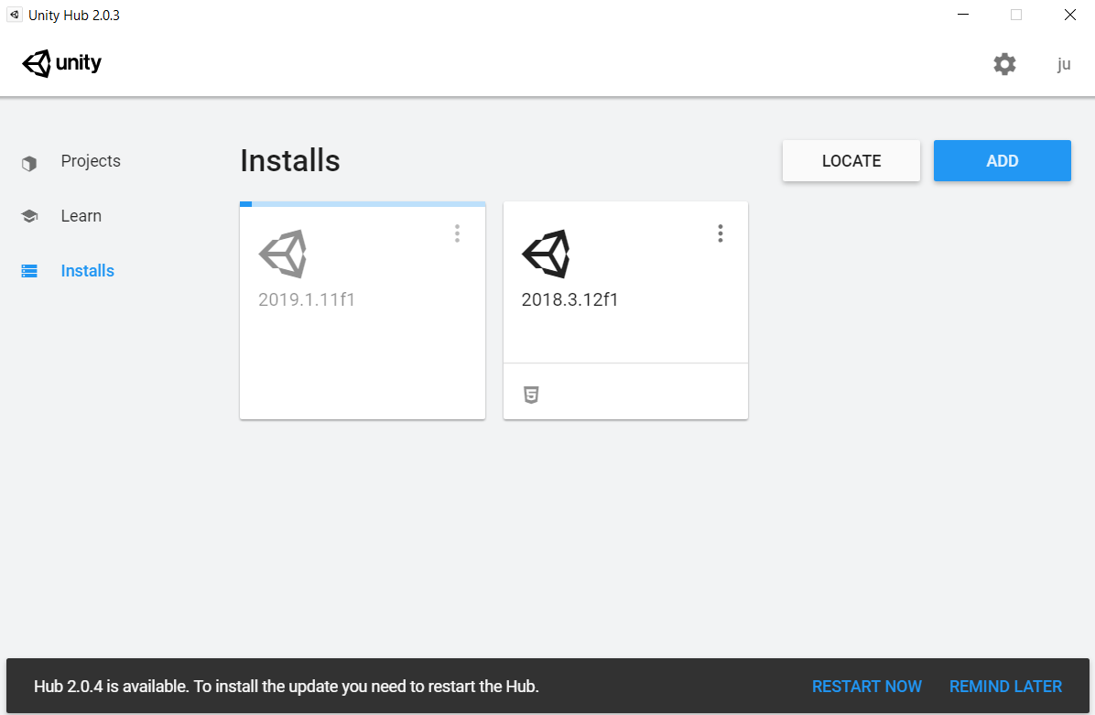

Unity Hub downloading and installing progress.

##### CryEngine

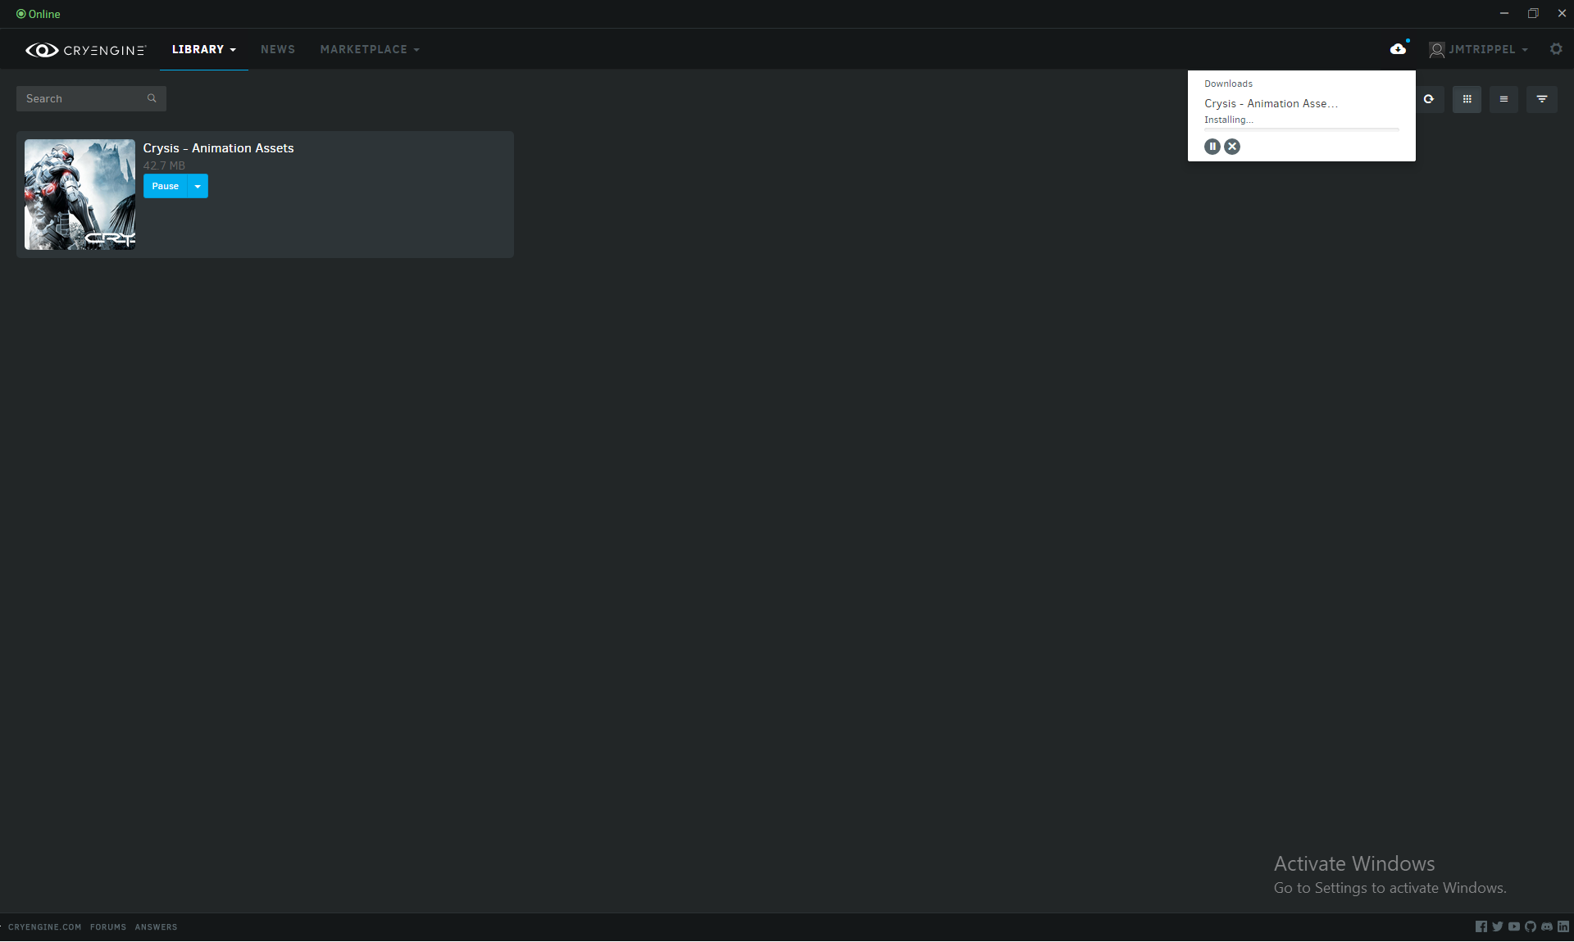

Downloading and installing progress.

**References:**

1. Source code of class that manage the HTTP downloads:<https://github.com/CRYTEK/CRYENGINE/blob/3ea599c619a30ee406dc3c9fd02a3427b597279c/Code/CryEngine/CrySystem/HTTPDownloader.cpp>

##### Epic Games

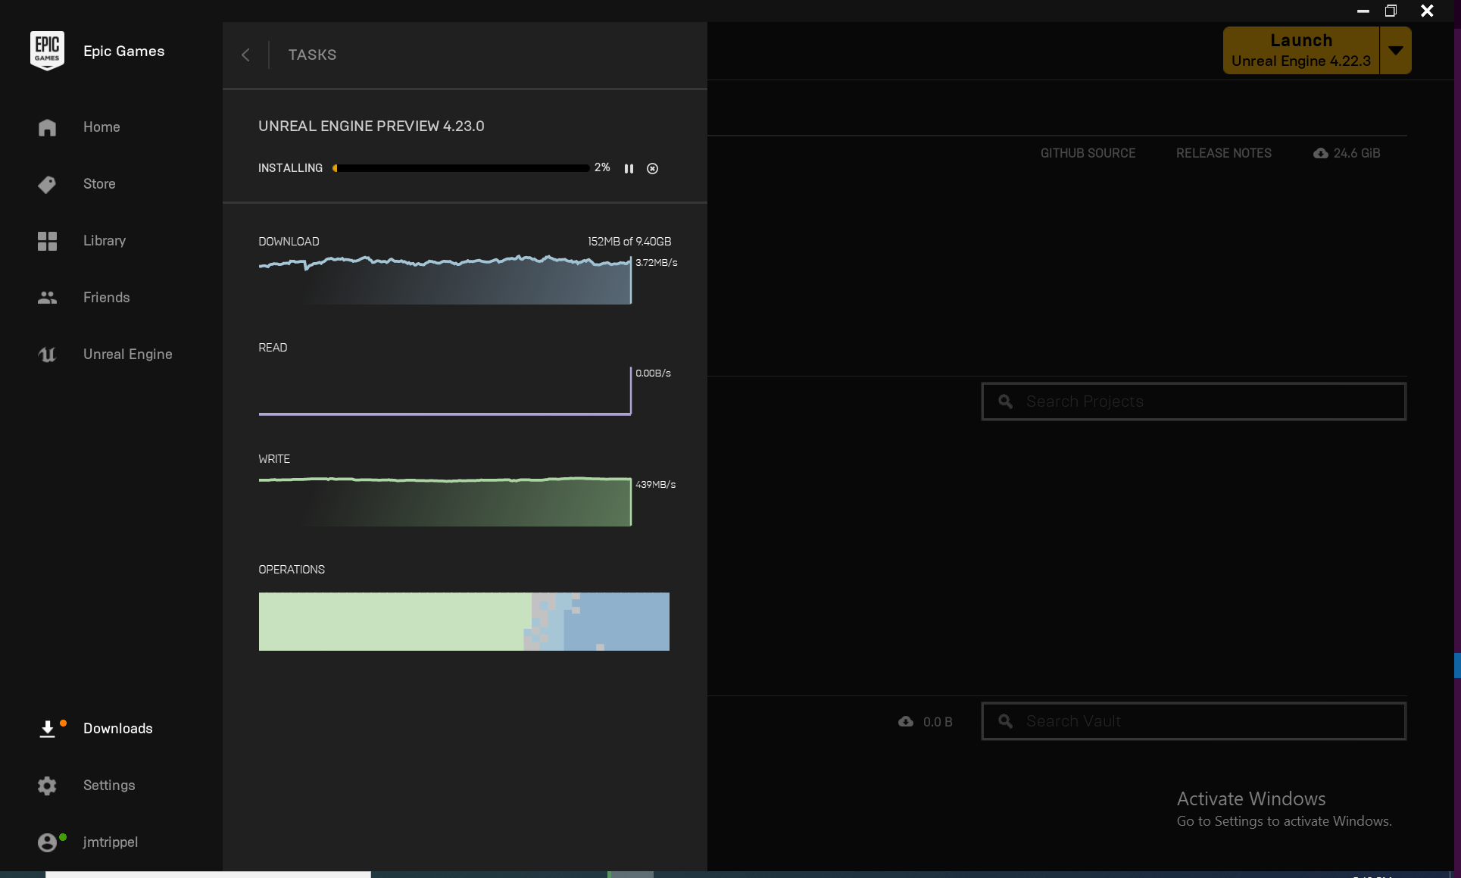

Downloading and installing progress, with some more information, read and write speed.

##### Amazon Lumberyard

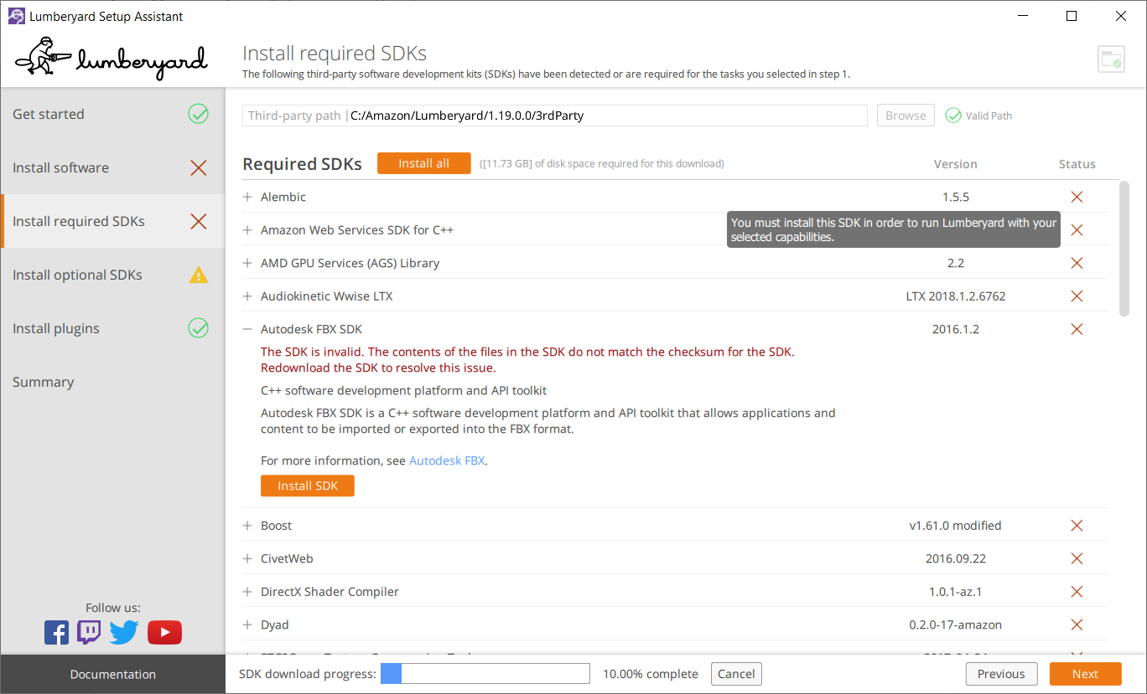

Downloading and installing progress.

**References:**

1. Class that manage the HTTP request to a server: <https://github.com/aws/lumberyard/tree/44f7b2480f7a9839d3389b08f5945ef56092ebc4/dev/Gems/HttpRequestor/Code/Source>

### Project Management System

This module will provide the needed functionalities for easing the manage of the projects within the installed products.

#### Industry state

##### Unreal Engine

Inside "Unreal Engine/Epic Games Launcher" you can create, open and delete projects. You will find all of your projects under the Library tab.

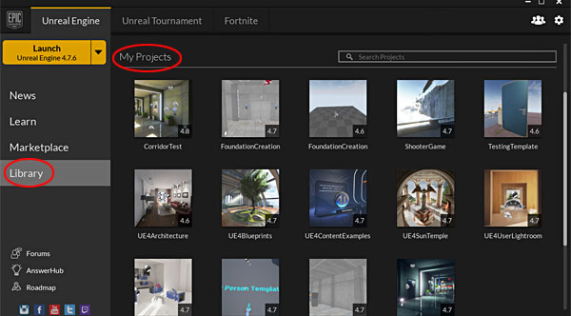

My projects section inside Library.

##### PopcornFX

You can create new projects, add existing projects, download online example packages, and import them into projects.

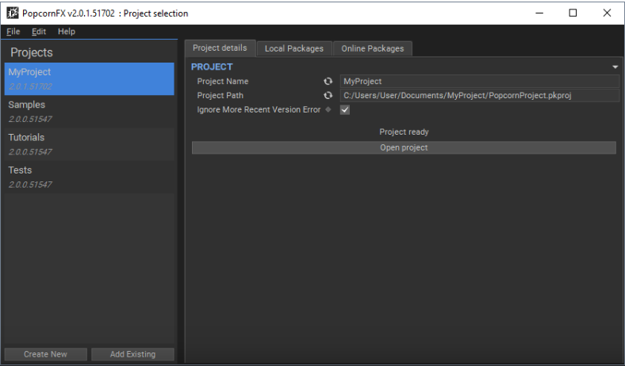

The project launcher is the starting hub view showing all PopcornFX projects.

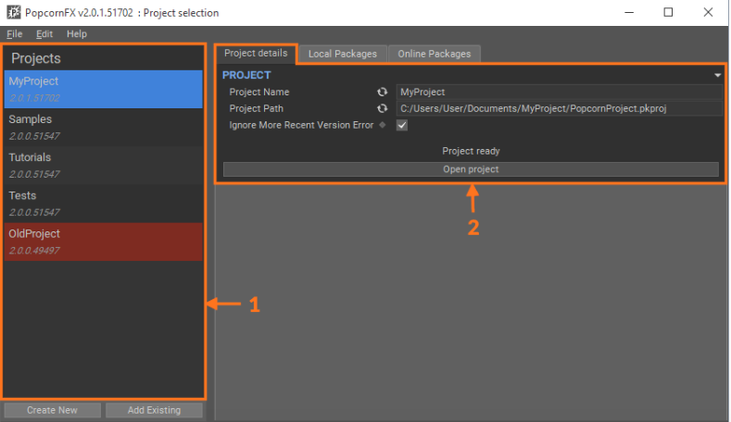

A PopcornFX project contains all effects and resources for a given project. Projects are created for a specific game engine so everything is properly setup but can easily be exported to various game engines.

**References:**

1. <https://www.popcornfx.com/docs/popcornfx-v2/editor/project-launcher/>

##### Amazon Lumberyard

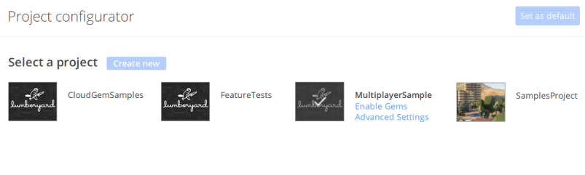

Project list with creation option.

**References**:

1. <https://github.com/aws/lumberyard/tree/master/dev/Code/Launcher/WindowsLauncher>

#### 

### Extension management

This module will handle the life cycle of product extensions. In a first approach the extensions could be managed within each particular product, however it would simplify the UX if the marketplace where the extensions will be consumed is provided within the HUB.

#### Industry state

##### Unity

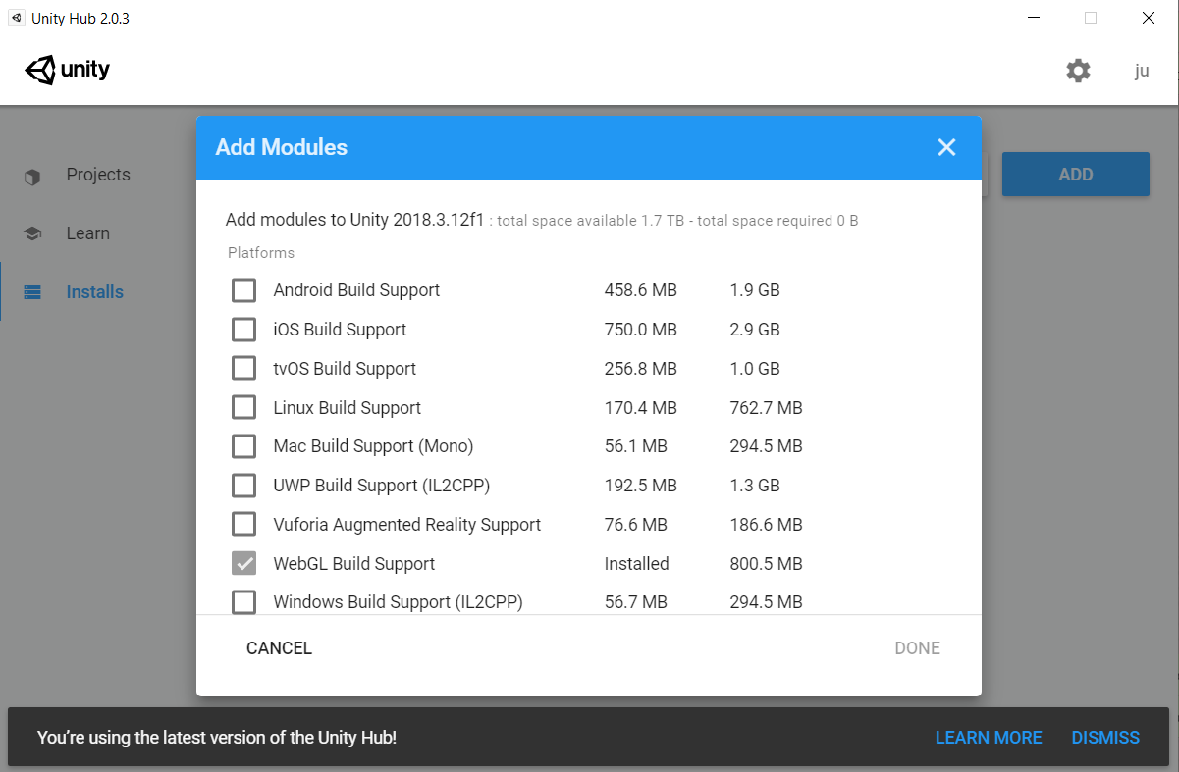

To install any module in Unity Hub a module selection modal is displayed.



In the bottom of each install, a list of icons that represent the installed modules for that installation is shown.

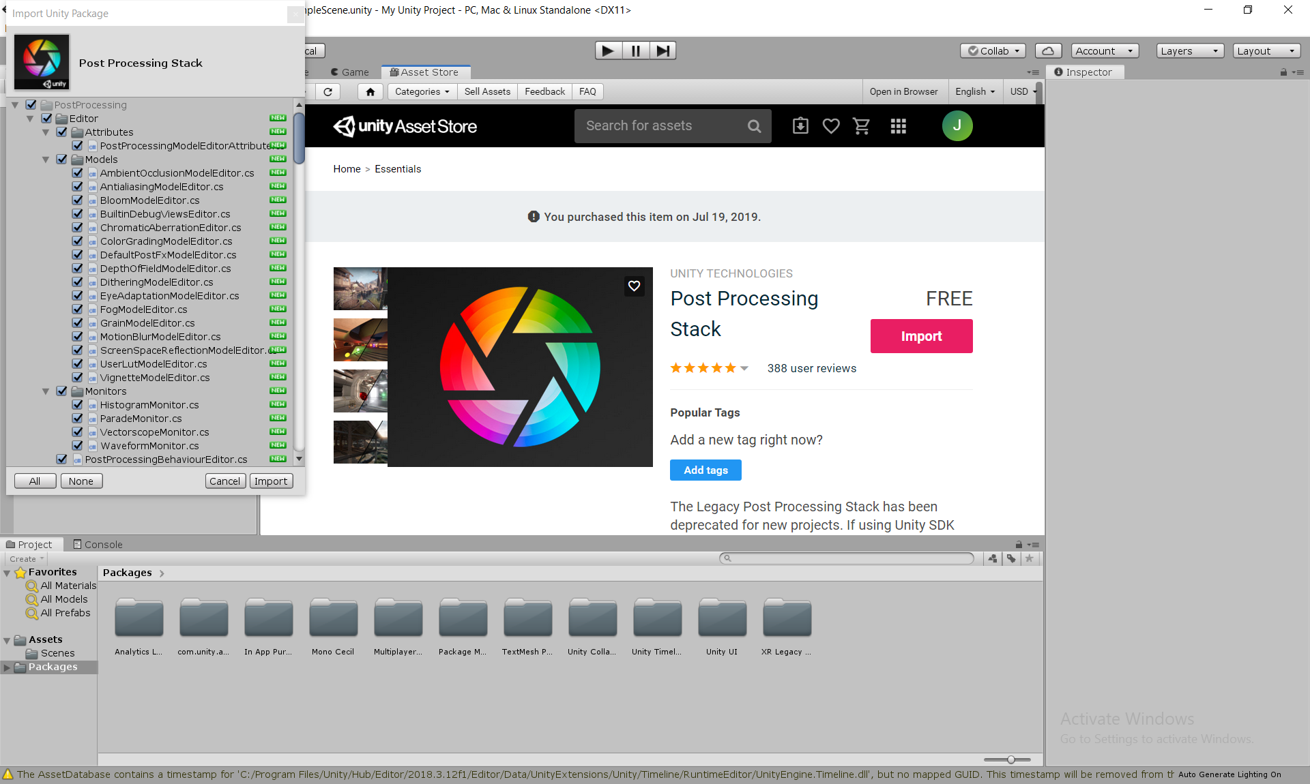

Within the Unity IDE the user can access to an Asset Store where he can download the needed assets.

##### CryEngine

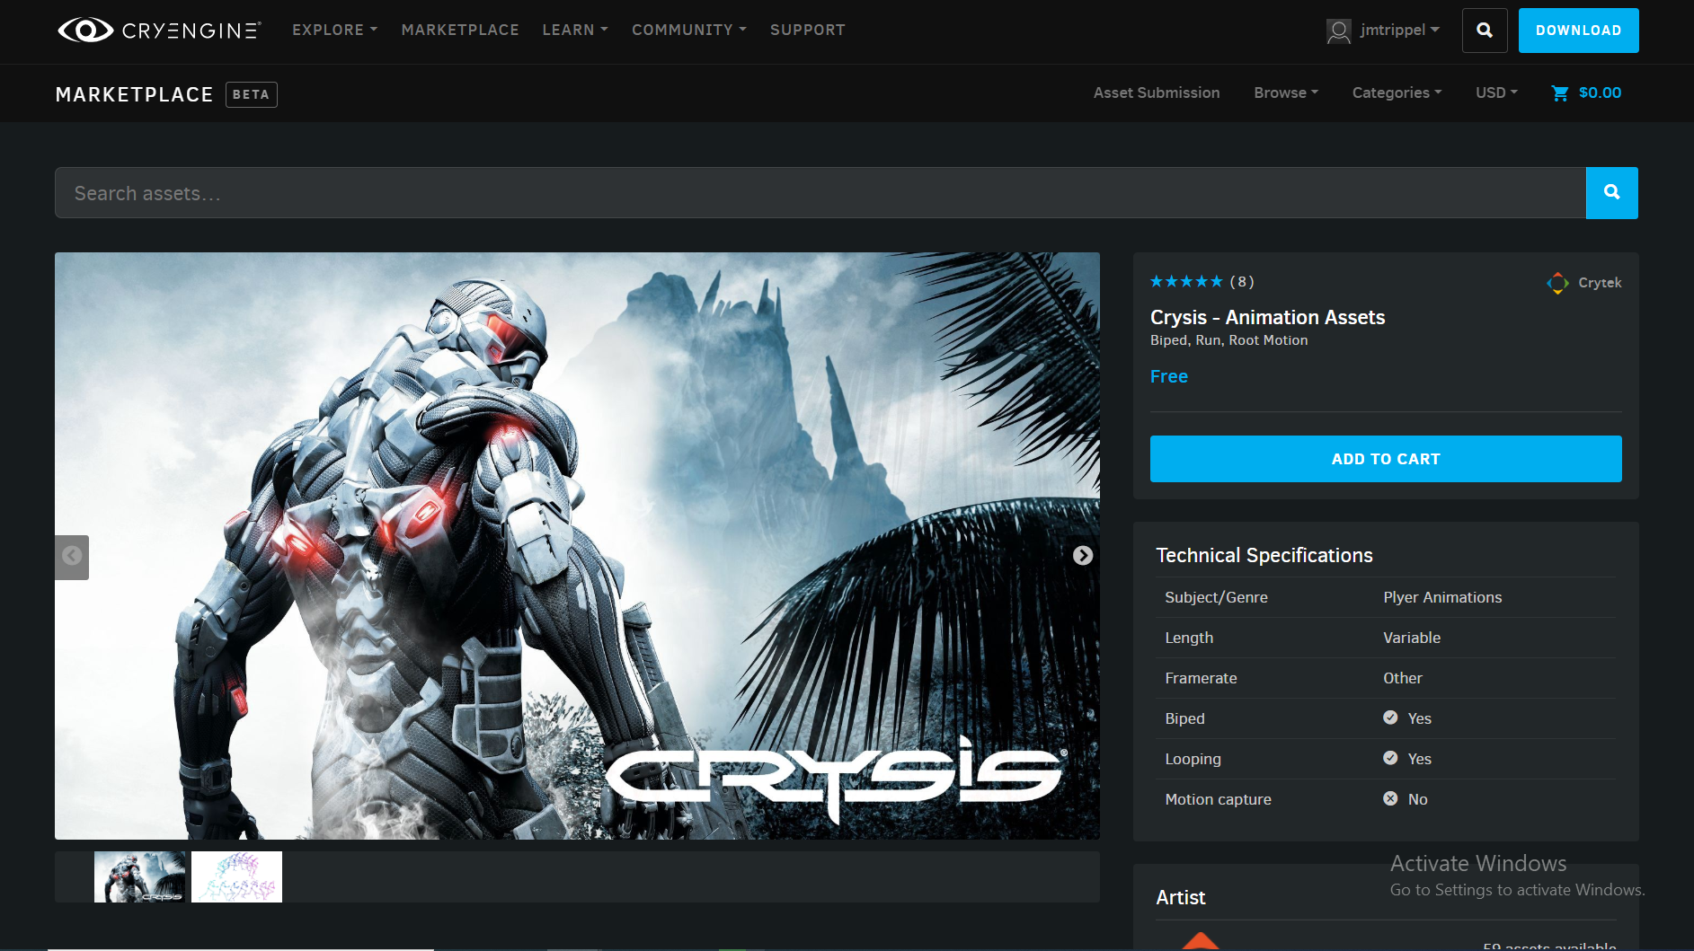

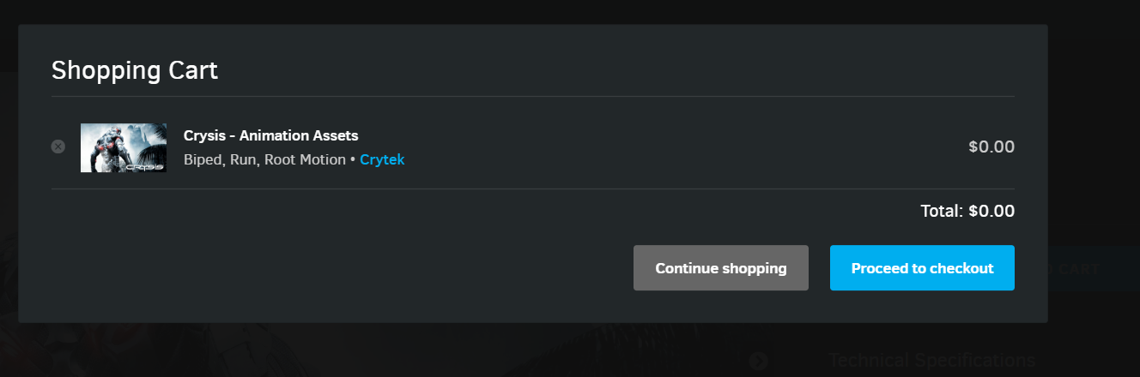

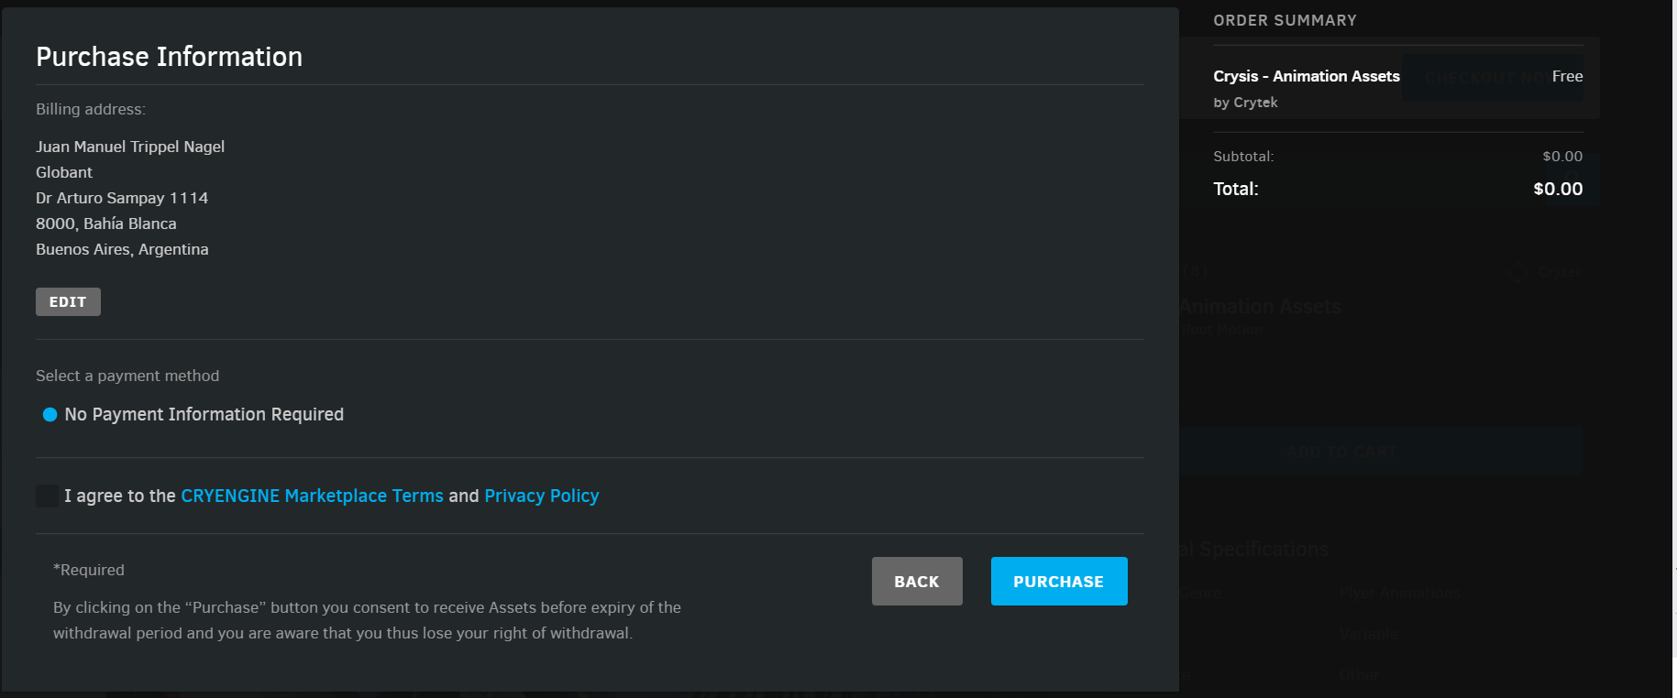

CryEngine provides an embedded marketplace where the whole purchasing process is contained in a single UX.

Top) Product description. Middle) Shopping cart checkout. Bottom) Purchase information and confirmation.

##### Amazon Lumberyard

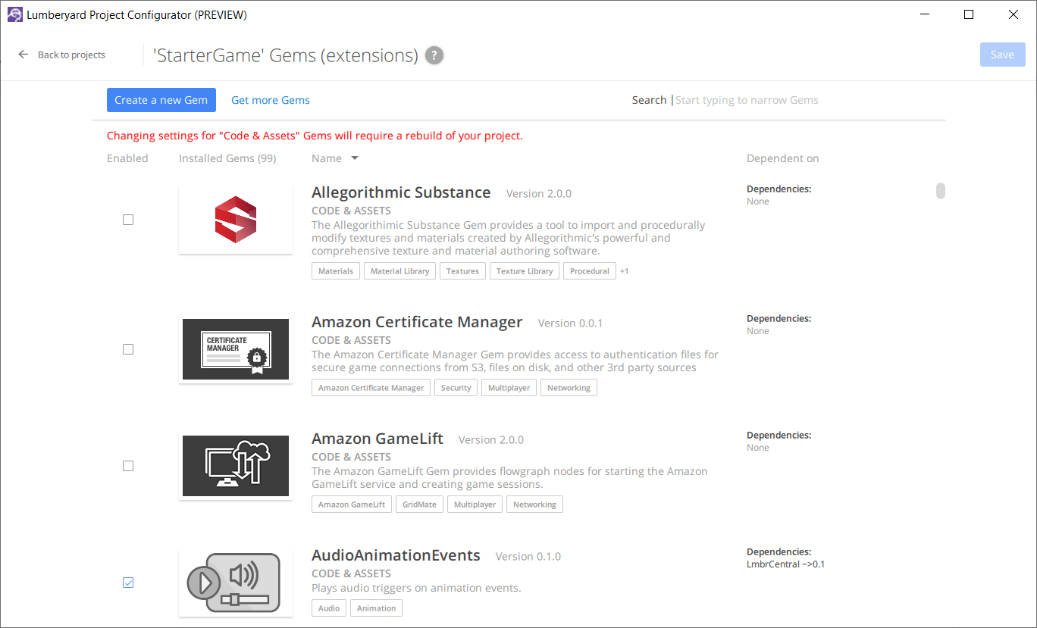

Lumberyard delivers a view where the user can consume “gems”, which can be either source code or assets, and then use them in any project.

**References:**

1. Lumberyard gems system: <https://docs.aws.amazon.com/es_es/lumberyard/latest/userguide/gems-system-gems.html>
2. Lumberyard gems system structures:

<https://docs.aws.amazon.com/es_es/lumberyard/latest/userguide/gems-system-structure.html>

##### Epic Games

###### 

###### 

Epic Games Launcher contains a similar UX as CryEngine.

Top) Product description. Middle) List of plugins per engine. Bottom) Plugin installation to an engine.

### Registry Management

This module maintains a lightweight registry of installed software products, extensions and projects.

Responsibilities:

1. Maintain a **registry** of products-versions, and extensions installed in the local machine also projects of the installed products.
   1. Add/remove a product from the registry.
   2. Add/remove an extension from the registry.
   3. Add/remove a project from the registry.
2. Support some queries to the stored data:
   1. Filter, Select.

**Windows installer structures**

Windows Installer is a software component and application programming interface (API) of Microsoft Windows used for the installation, maintenance, and removal of software. The installation information, and optionally the files themselves, are packaged in installation packages, loosely relational databases structured as COM Structured Storages and commonly known as "MSI files", from their default filename extensions.

1. **Package:** describes the installation of one or more full **products** and is universally identified by a **GUID**. A product is made up of **components**, grouped into **features**. Windows Installer does not handle dependencies between products. A package includes the package logic and other **metadata** that relates to how the **package** executes when running.
2. **Product:** a single, installed, working program (or set of programs) is a product. A product is identified by a unique **GUID** (the **ProductCode** property) providing an authoritative identity throughout the world. The **GUID**, in combination with the version number (**ProductVersion** property), allows for release management of the product's files and registry keys.
3. **Features:** is a **hierarchical group of components**. A feature may contain any number of components and other sub-features. Smaller packages can consist of a single feature. More complex installers may display a "custom setup" dialog box, from which the user can select which features to install or remove.
4. **Components:** is the **basic unit** of a product. Each component is treated by Windows Installer as a unit. The installer cannot install just part of a component. Components can contain program files, folders, COM components, registry keys, and shortcuts. The user does not directly interact with components. Components are identified globally by GUIDs; thus the same component can be shared among several features of the same package or multiple packages, ideally through the use of Merge Modules.
5. **Key paths:** A key path is a specific file, registry key, or ODBC data source that the package author specifies as critical for a given component. Because a file is the most common type of key path, the term key file is commonly used. A component can contain at most one key path; if a component has no explicit key path, the component's destination folder is taken to be the key path. When an MSI-based program is launched, Windows Installer checks the existence of key paths. If there is a mismatch between the current system state and the value specified in the MSI package (e.g., a key file is missing), the related feature is re-installed. This process is known as self-healing or self-repair. No two components should use the same key path.

**Registry**

The registry is a local lite db where the information regarding installations and projects are stored. The db needs to contain at least the following structures:

|  |  |
| --- | --- |
| Package | Guid  Name  Version  SoftwareProduct |
| SoftwareProduct | Guid  Name  Version  BinariesUrl  Url |
| Extension | Guid  Name |
| Project | SoftwareProduct  Url |

**References:**

1. <https://github.com/aws/lumberyard/blob/0b34452ef270f6b27896858dc7899c9796efb124/dev/Code/Tools/GemRegistry/source/GemRegistry.cpp>

### Content Ingestion

This module will manage the acquisition and processing of learning resources, such as video streaming, images and documents.

#### Industry state

##### Unity

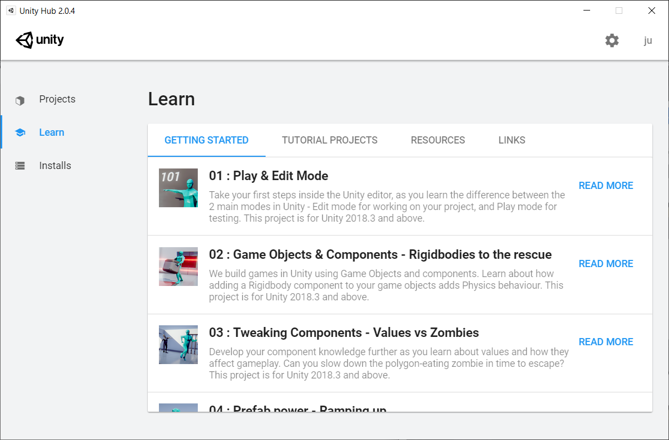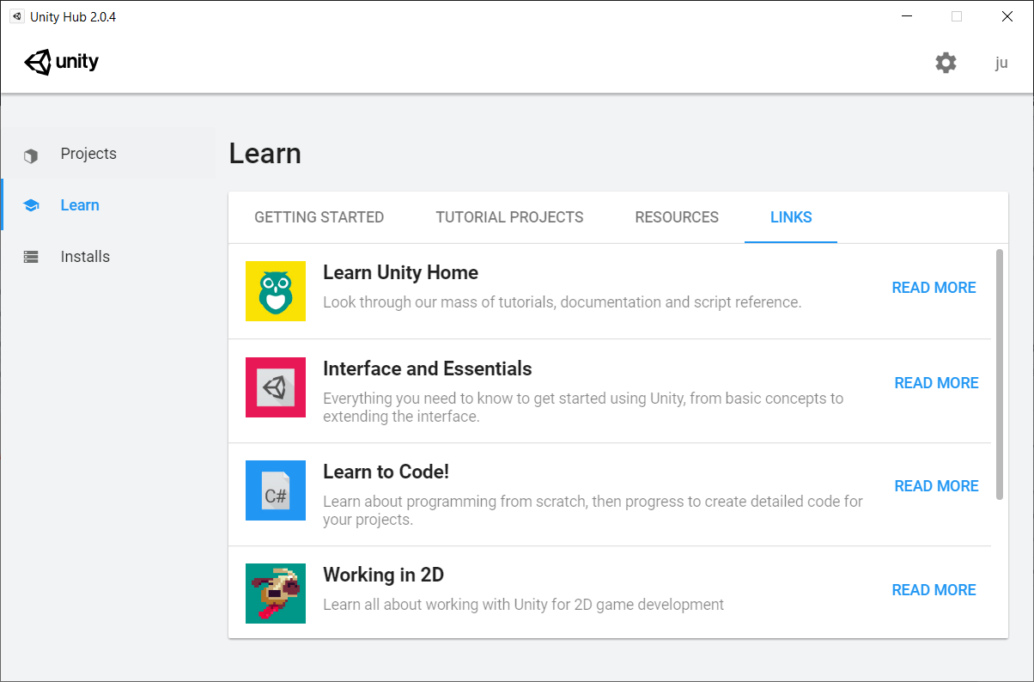

Unity Hub provides multiple resources for the user to consume in order to learn how to improve the usage of the engine.

##### Epic Games

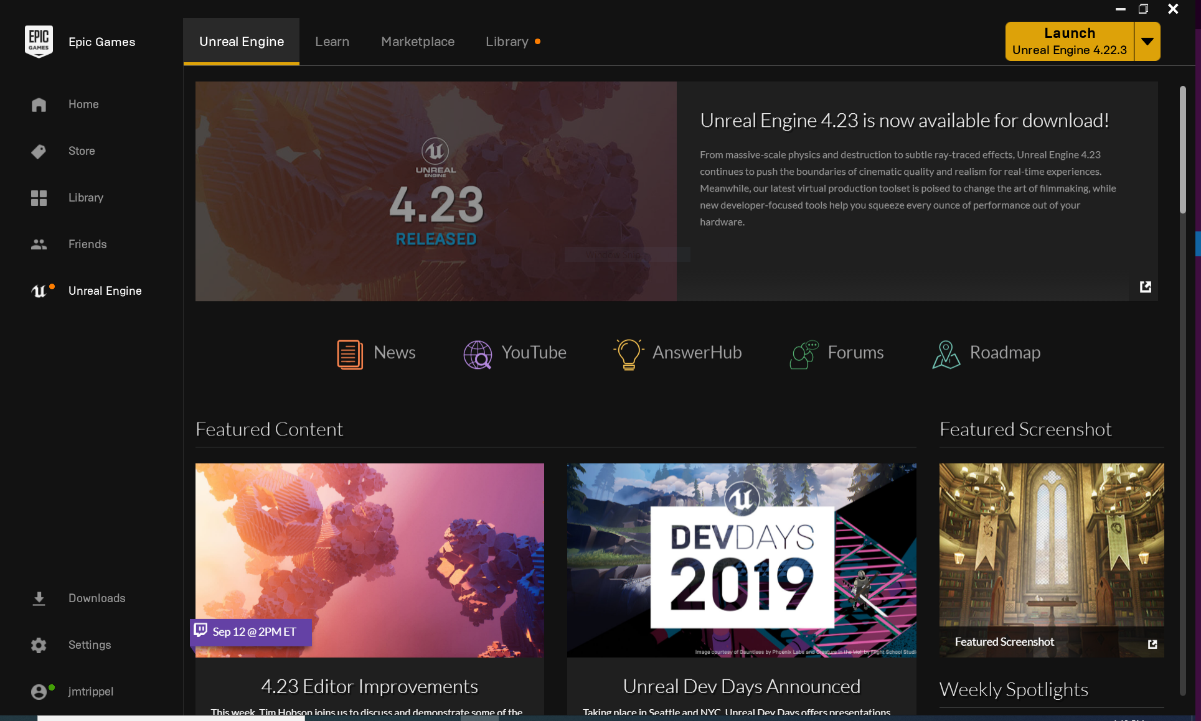

Epic Games also present a similar view with learning material.

##### CryEngine

#### 

As depicted in the image CryEngine offers the same kind of UX.

### Temptative design

#### Class diagram

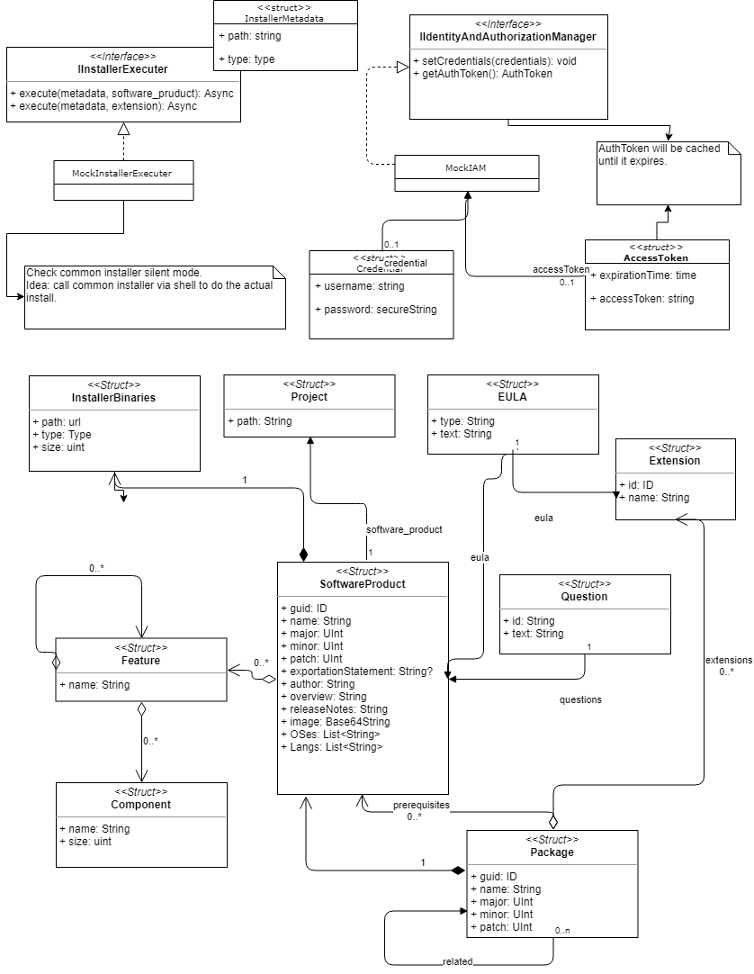

#### 

#### Interaction diagram for installing a package in remote targets.

#### Rest API

|  |  |  |  |
| --- | --- | --- | --- |
|  |  | Input | Output |
| /pm | /installable-packages | Access token | List of installable packages. |
|  | /installed-packages | Access token | List of installed packages. |
|  | /package-data/:guid | Access token  Package guid | Package information:   * Images * Overview * OSes * Languages * Features:   + Components |
|  | /package-exists/:guid | Access token  Package guid | Check if package is installed. |
|  | /package-install-data/:guid | Access token  Package guid | Package install information:   * EULAs * Features:   + Components |
|  | /package-update/:guid | Access token  Package guid | Package updates if available. |
|  | /install | Access token  Url  Package  Target | Task:   * Id * Description * Target * Package |
|  | /installTasksQueue | Access token | List of tasks that are in the queue for downloading:   * Id * Description * Target * Package * Progress * Max * Rate * Active |

|  |  |  |  |
| --- | --- | --- | --- |
|  |  | Input | Output |
| /idm | /access-token | Credentials | Access token |

|  |  |  |  |
| --- | --- | --- | --- |
|  |  | Input | Output |
| /dm | /targets | Access token | List of available targets |

|  |  |  |  |
| --- | --- | --- | --- |
|  |  | Input | Output |
| /btm | /install | Access token  Url  Package  Target | Task:   * Id * Description * Target * Package |
|  | /installTasksQueue | Access token | List of tasks that are in the queue for downloading:   * Id * Description * Target * Package * Progress * Max * Rate * Active |

## HUB UI

**Features**

1. Requests to local HUB service.
2. Provides a unified UX for multiple process.
3. Two modes of work:
   1. Admin.
   2. Lightweight.

#### 

|  |  |  |  |  |
| --- | --- | --- | --- | --- |
|  | Life cycle | Download | Digital Content | Projects |
| Admin | Local and remote:   * Install * Update * Patch * Remove   List of installed products local and remote. | * Download binaries from internet. * Export/import to media. | * Consume Rockwell Automation content (content related with IT admin) | Launches local projects. |
| Lightweight | Local or request admin:   * Install * Update * Patch * Remove   Every action can be enabled/disabled.  List of local installed products. | * Download binaries from internet. |  | Launches local projects. |

### Mockups

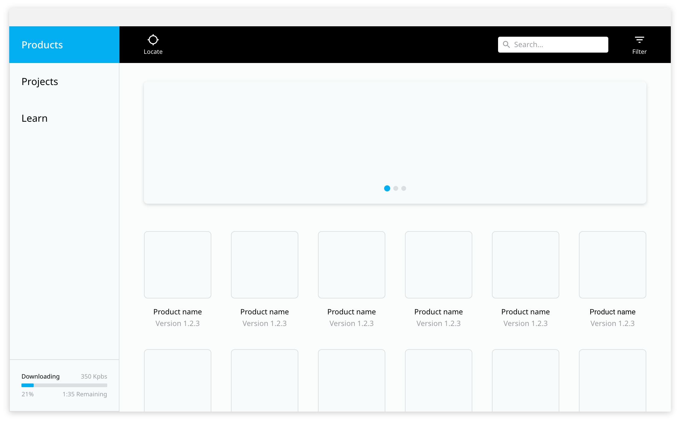

Products home without any installed product.

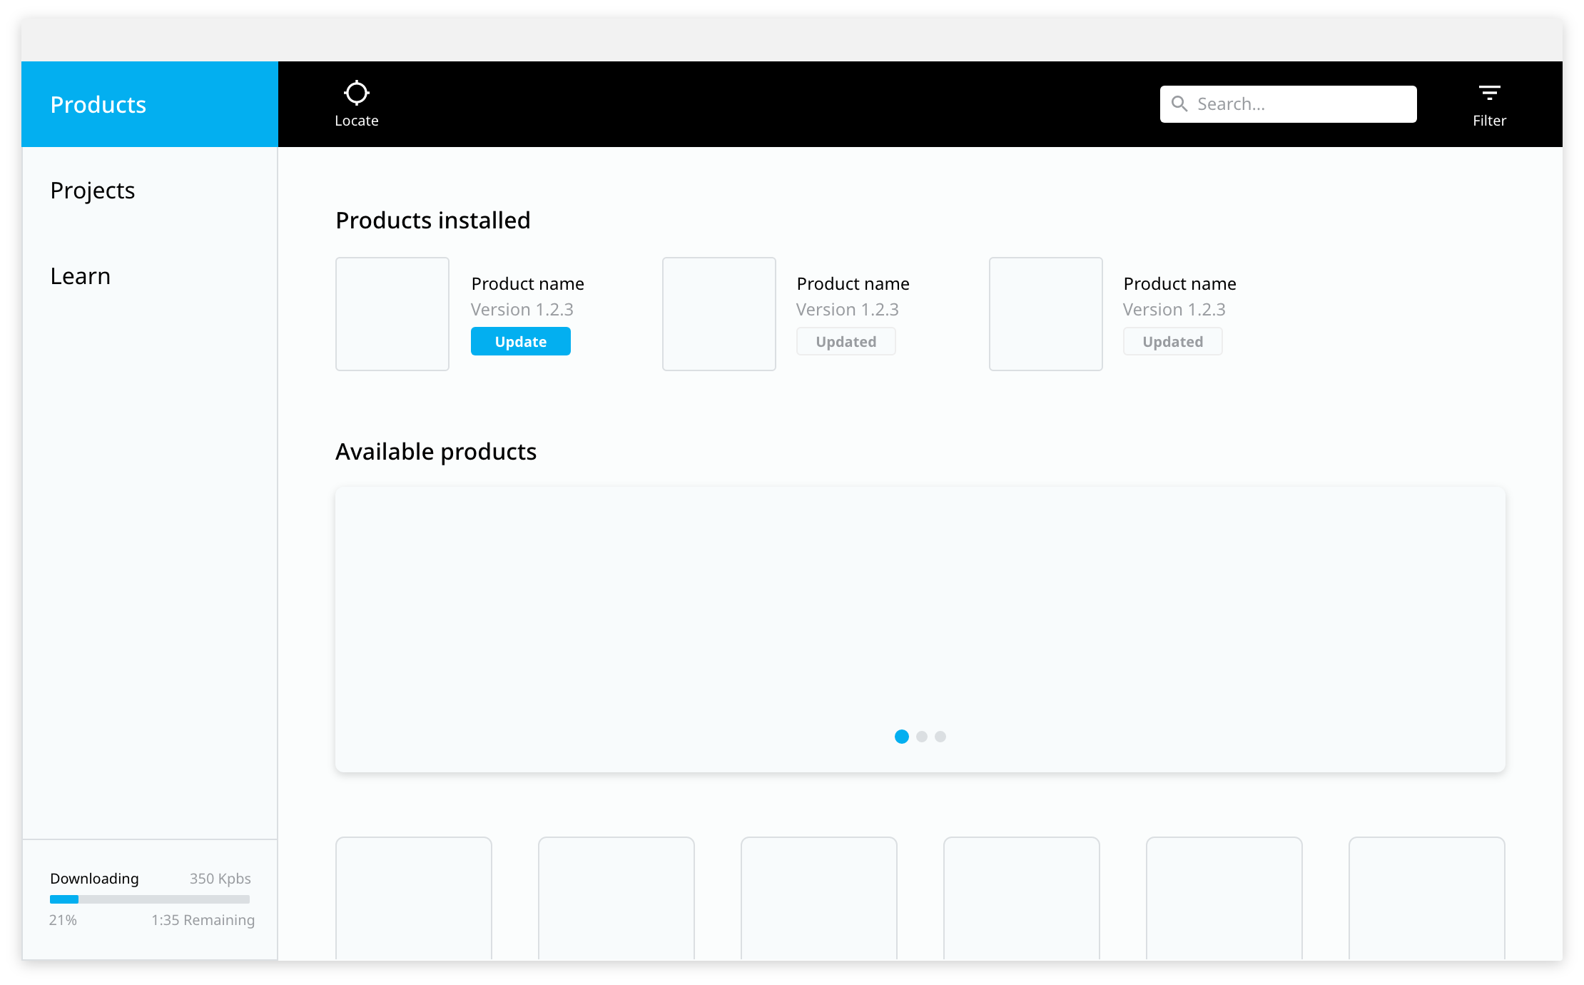

Products home with some installed product.

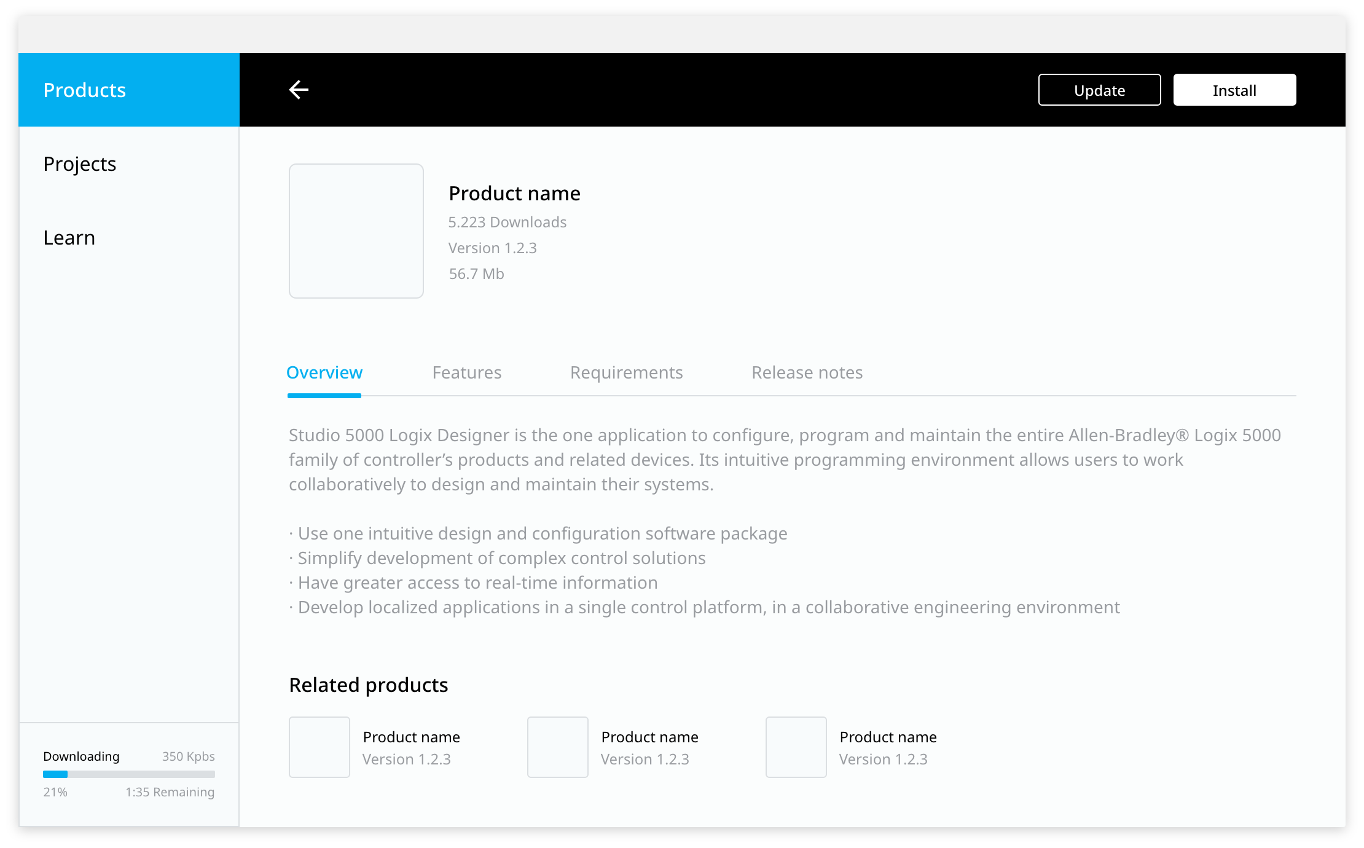

Product description, specifying the different features, requirements and release notes.

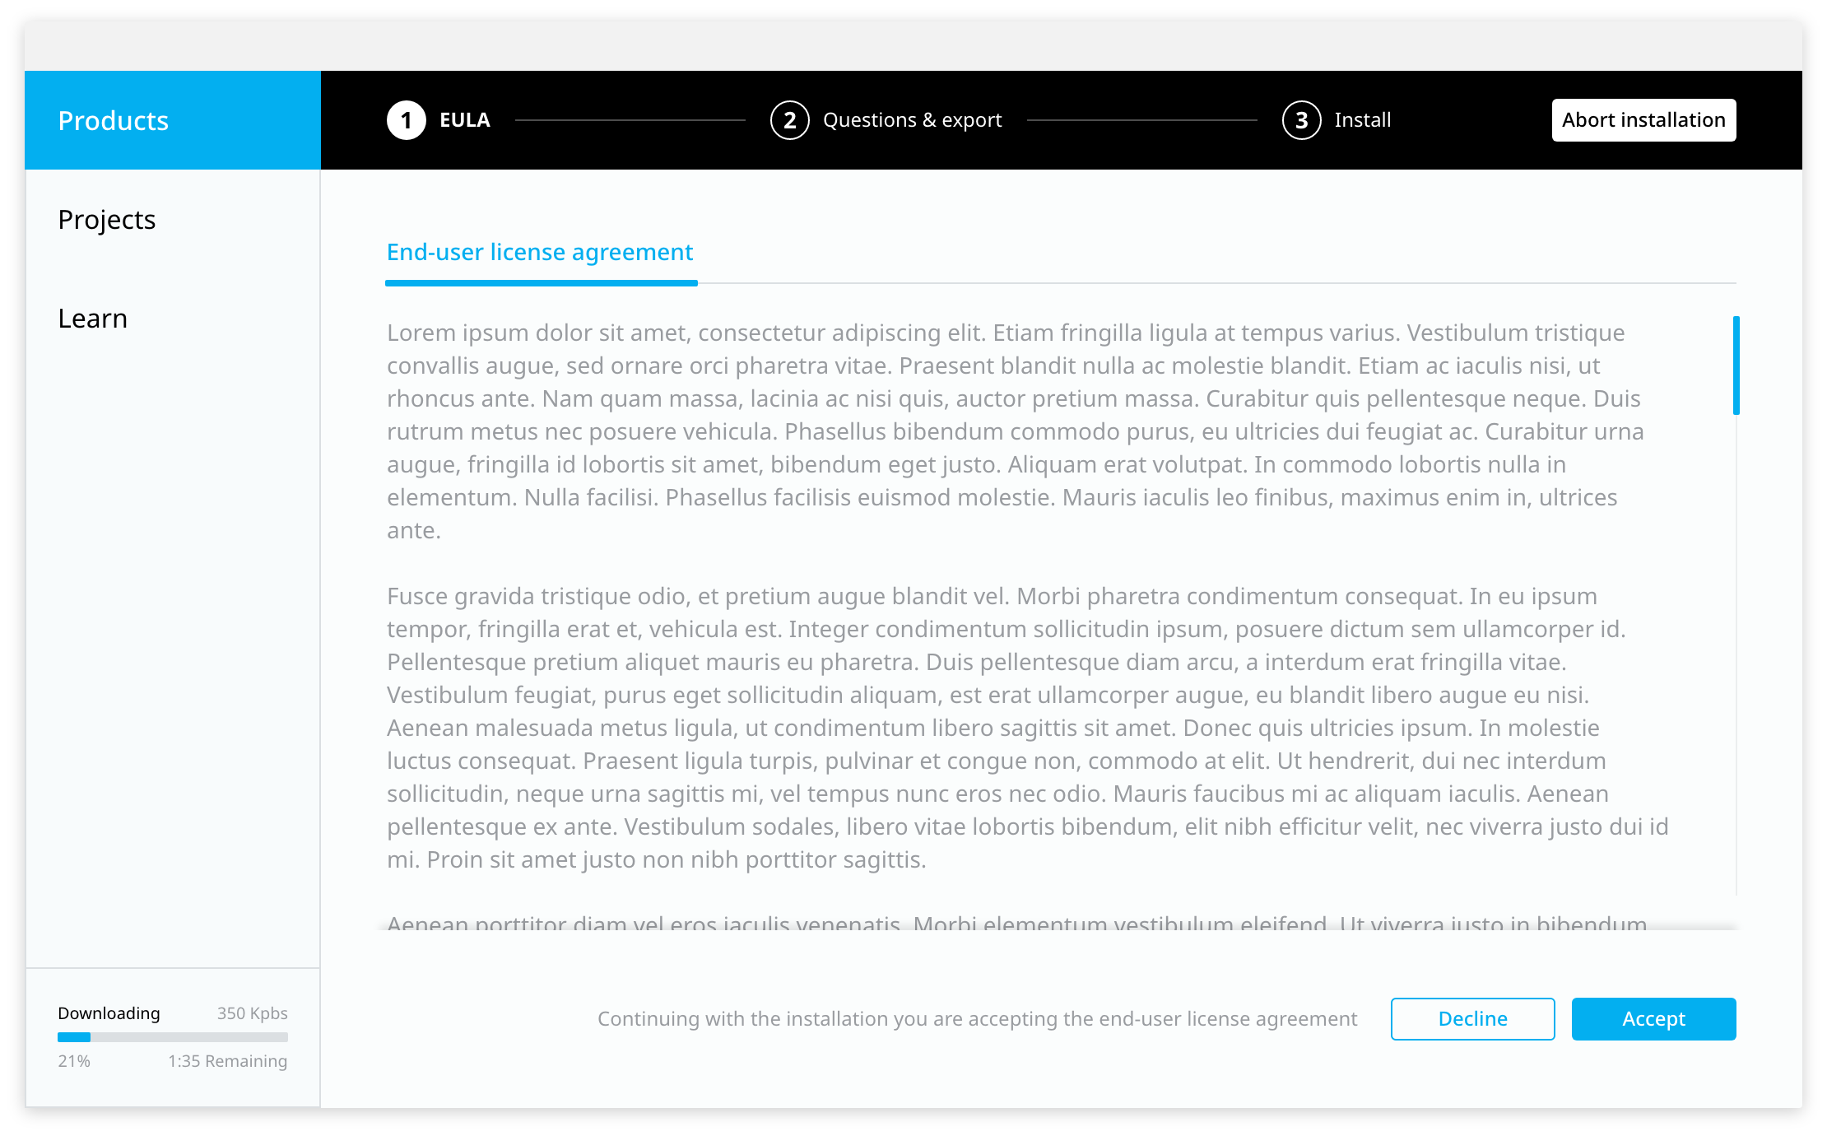

Terms and conditions of the different products.

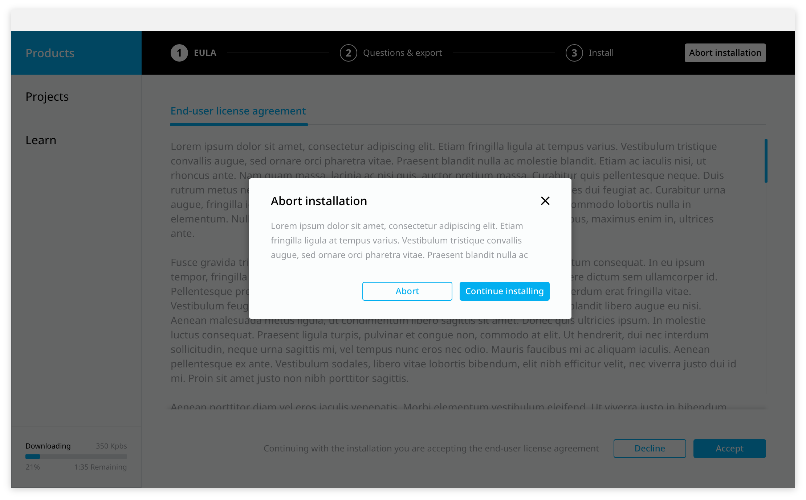

Confirmation to cancel the product installation.

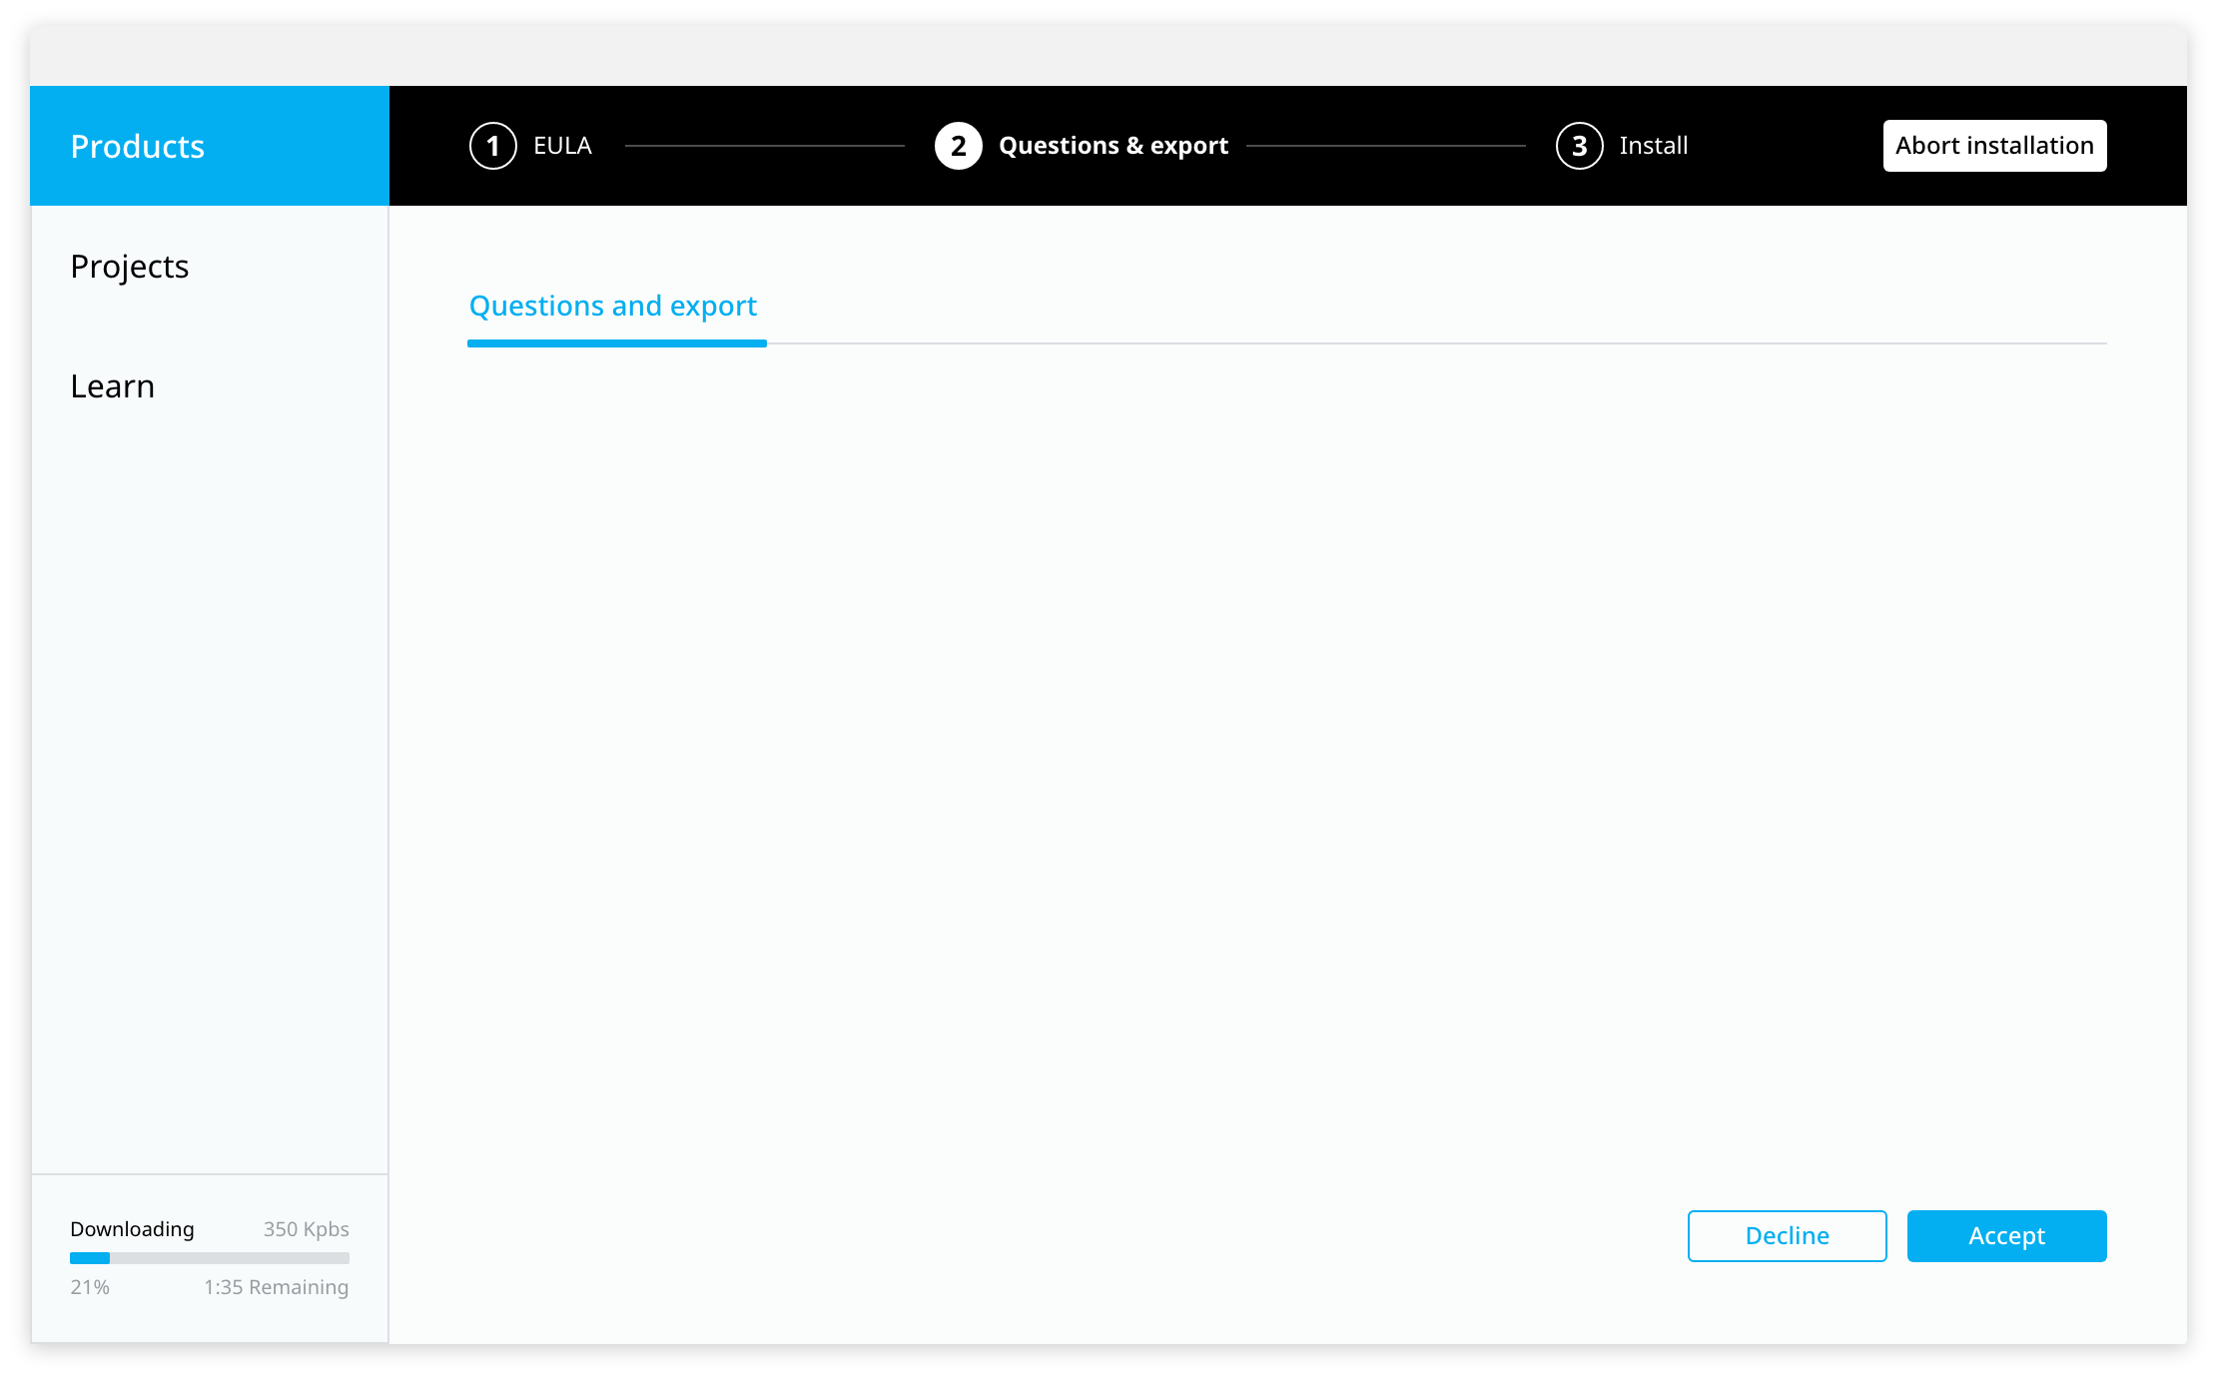

Questions and export.

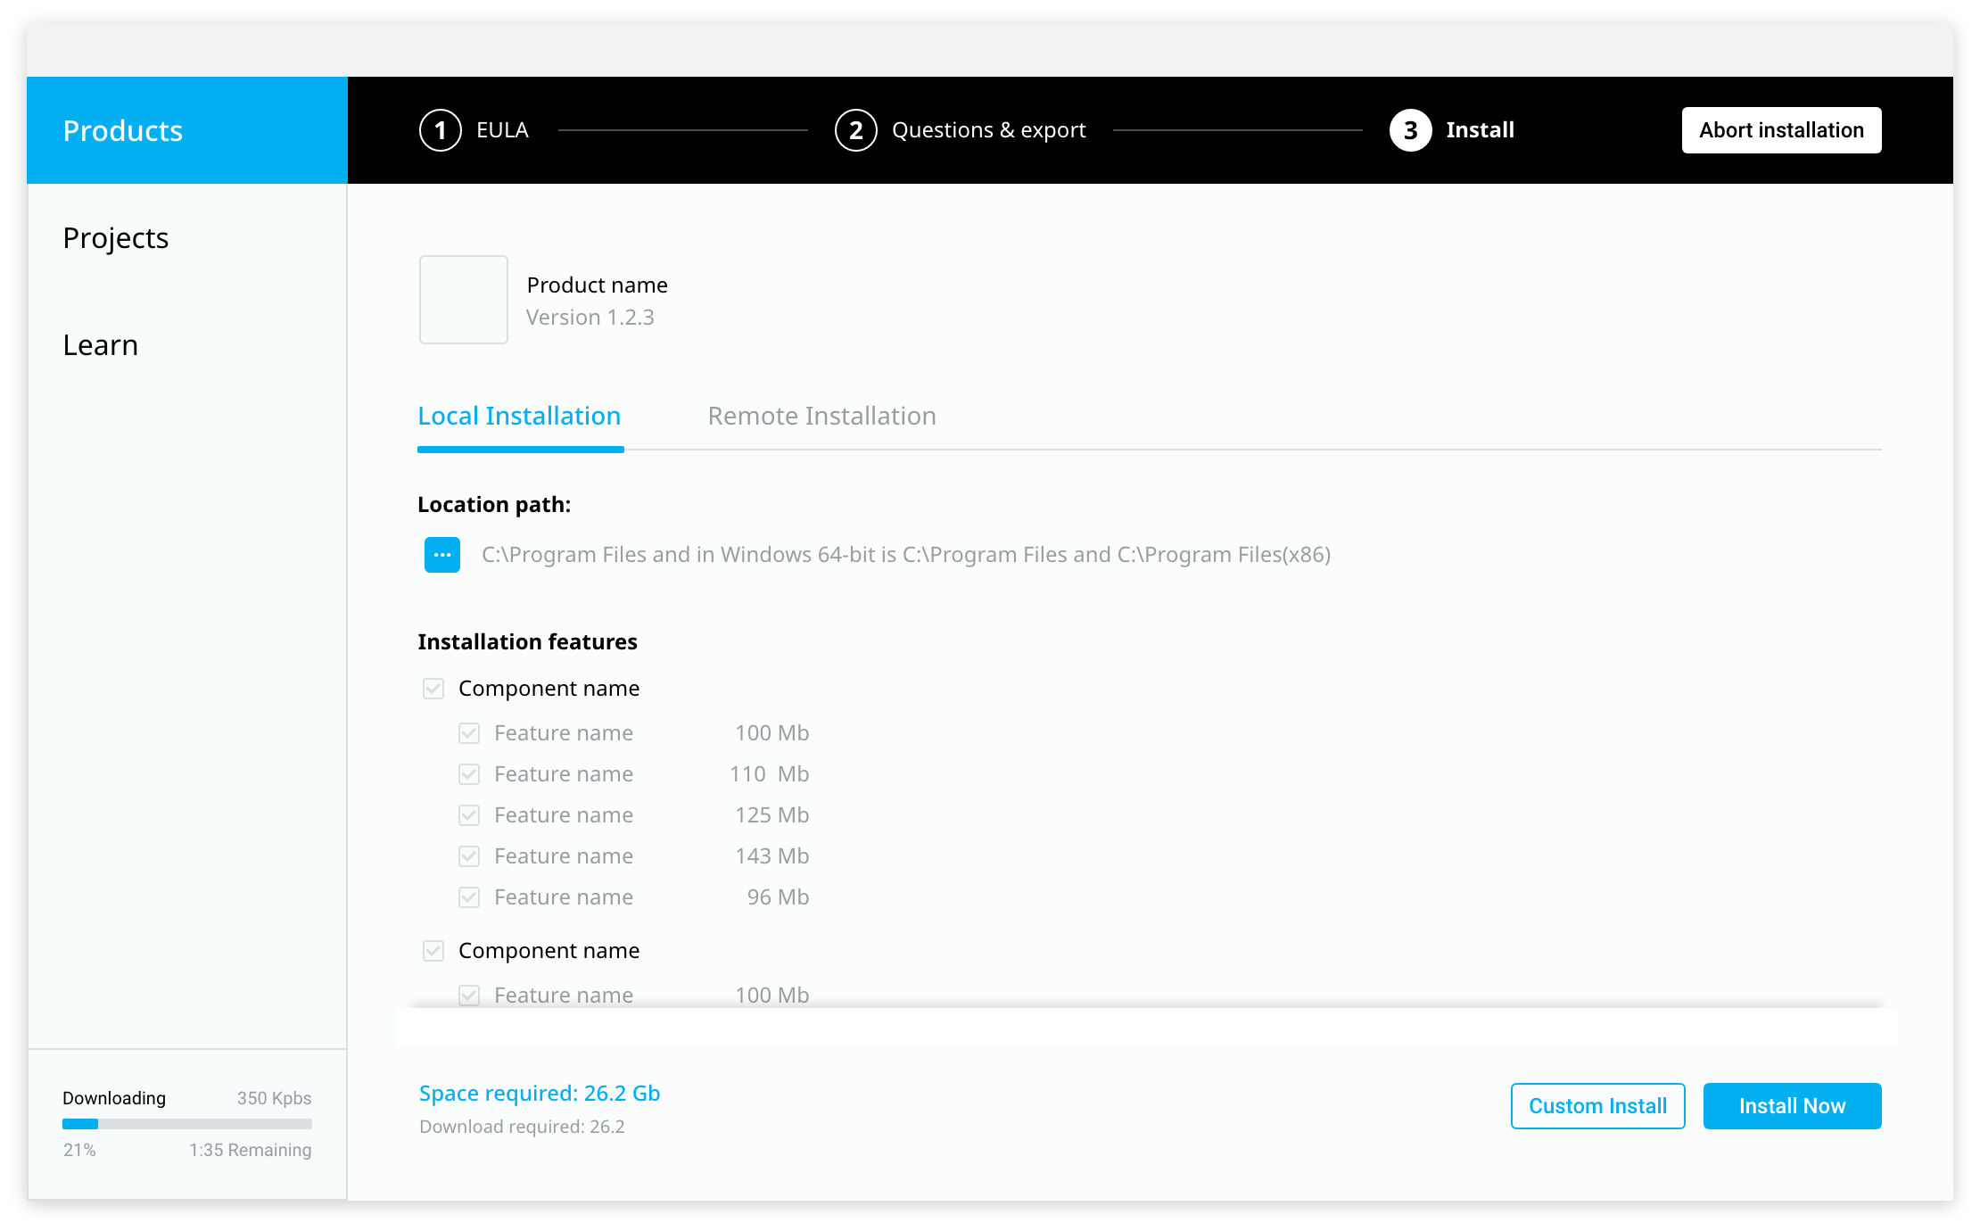

Local installation of the selected product.

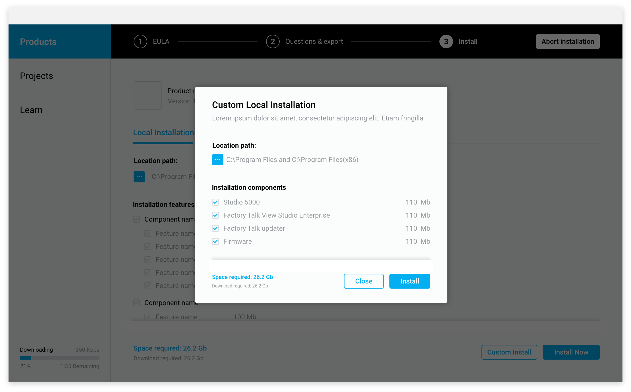

Custom installation of the selected product.

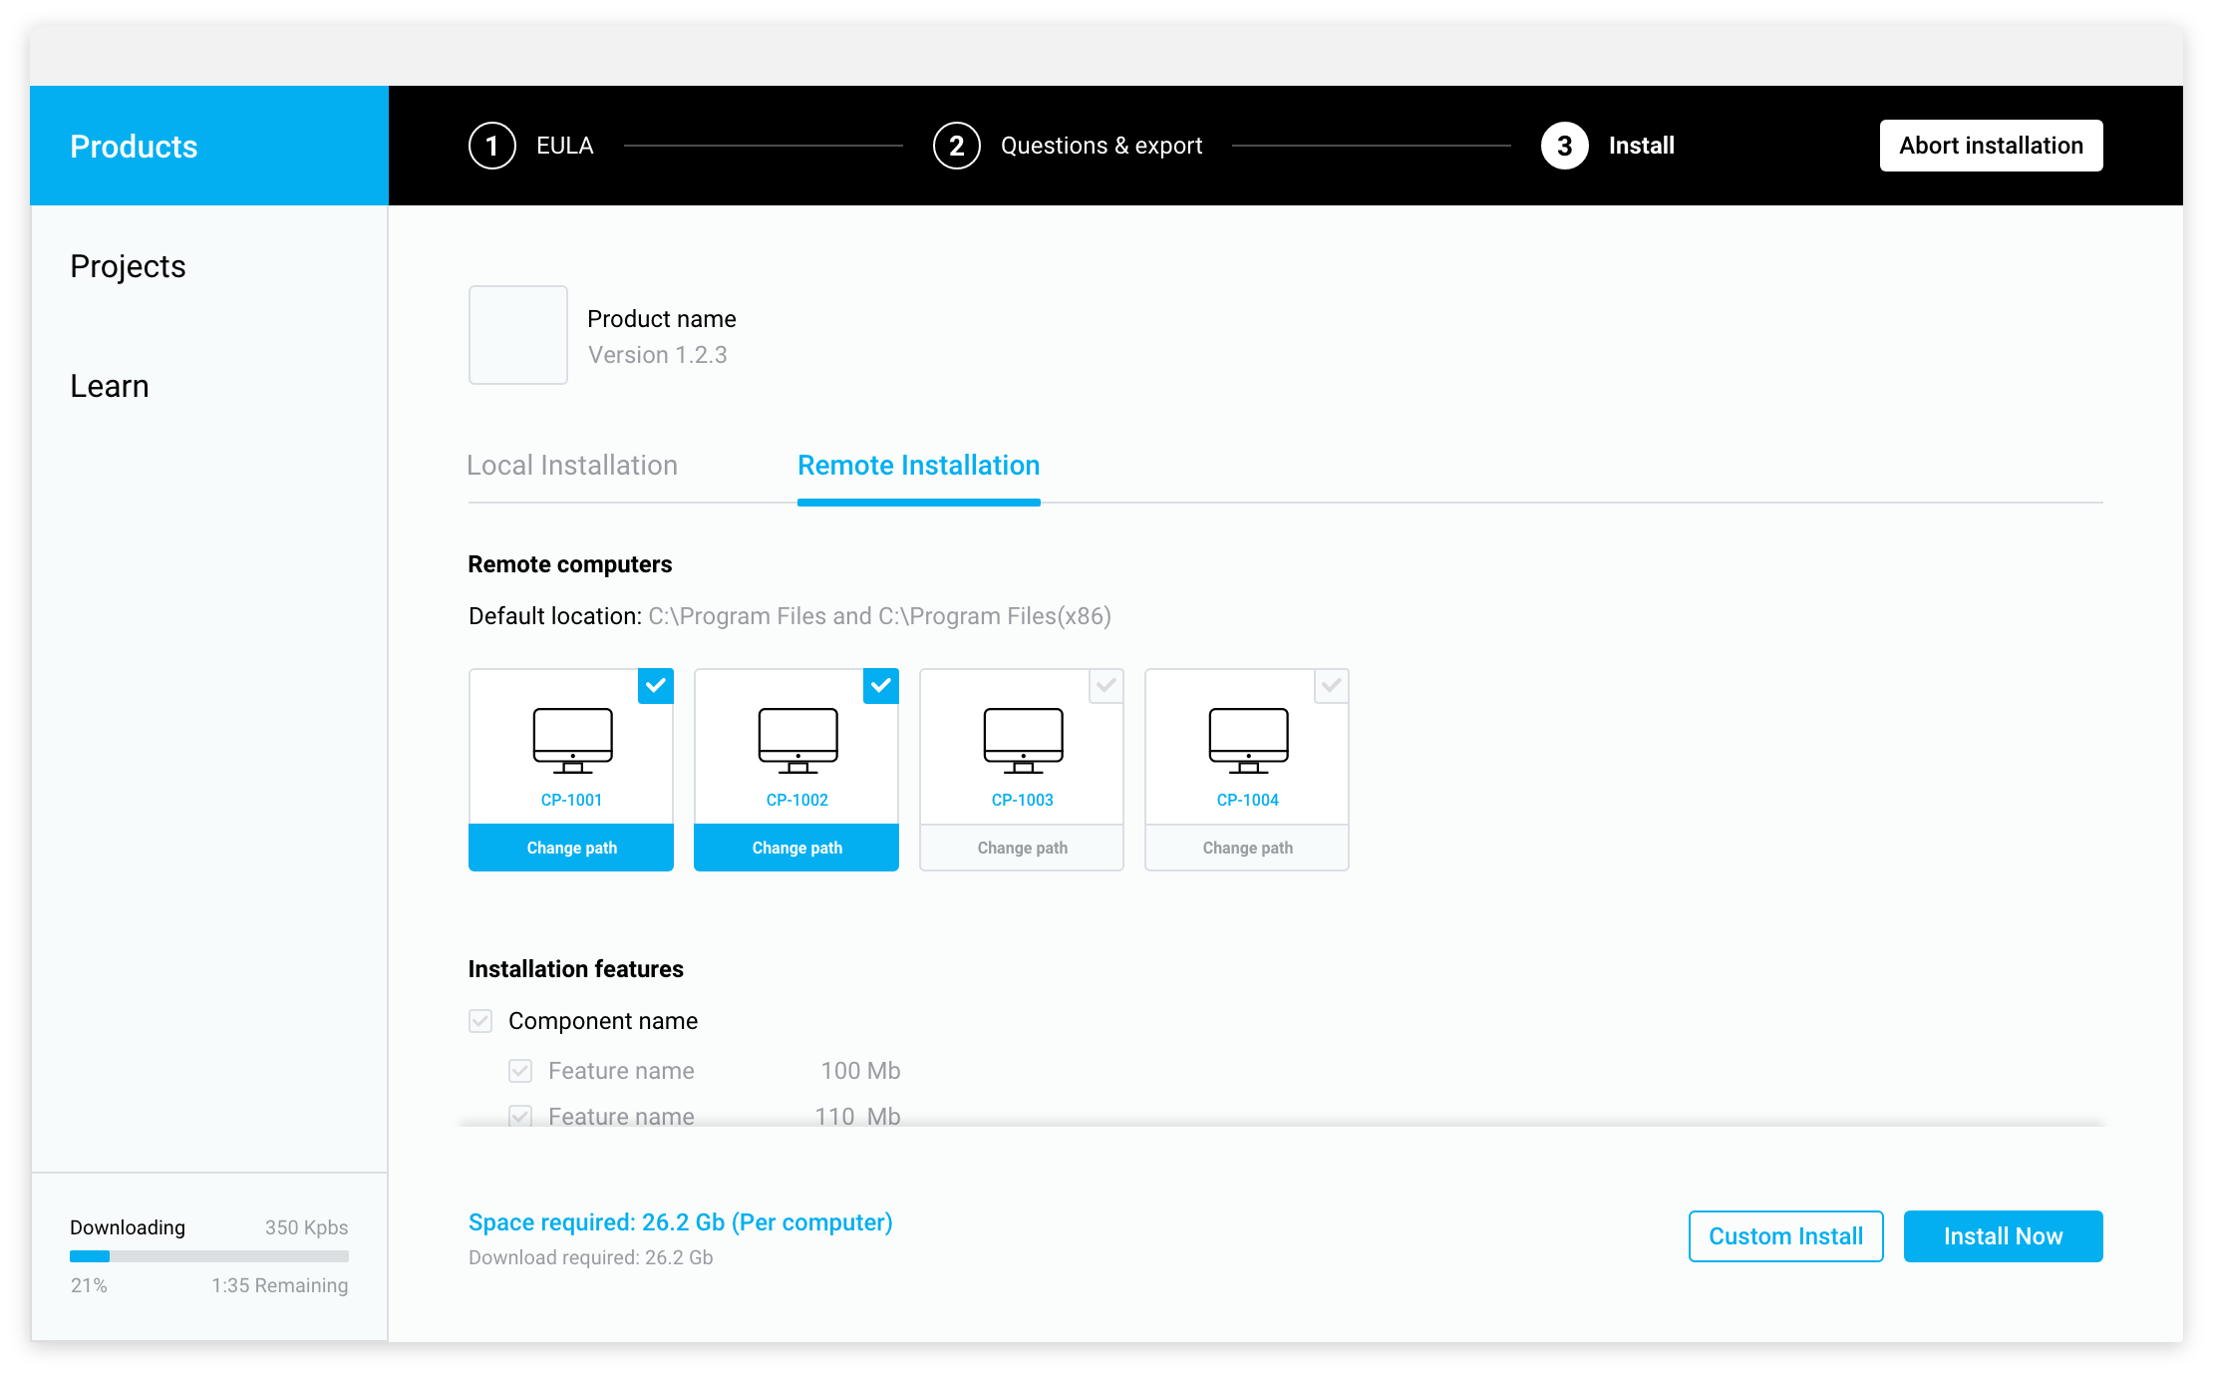

Remote installation of the selected product.

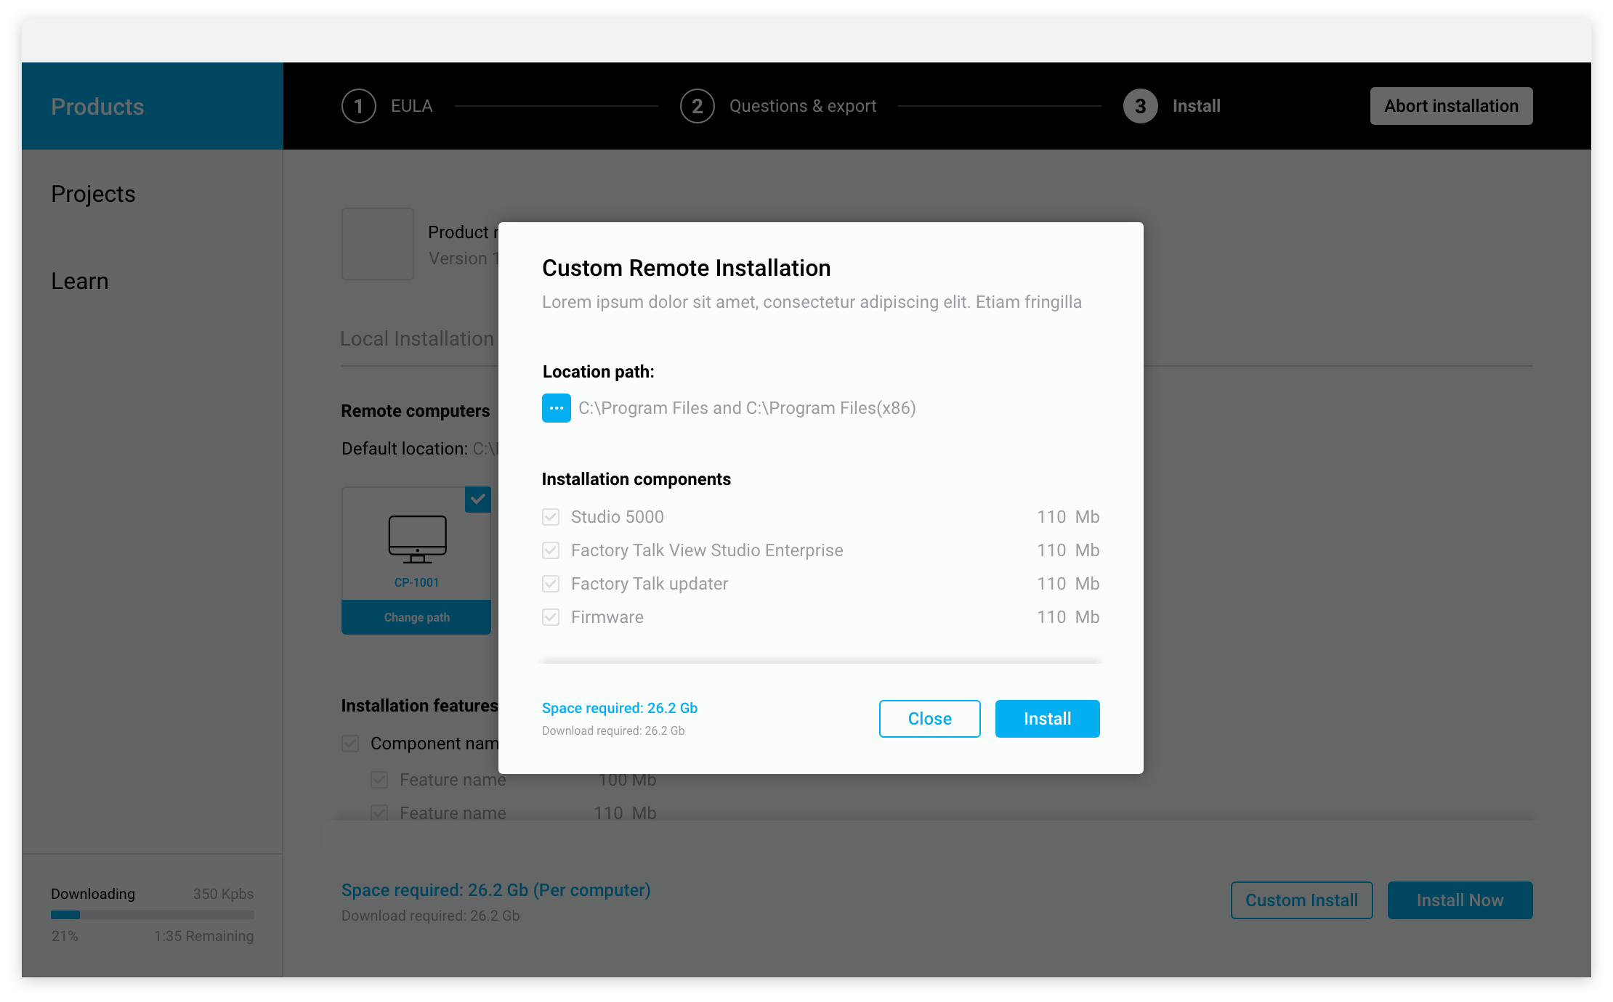

Custom remote installation of the selected product.

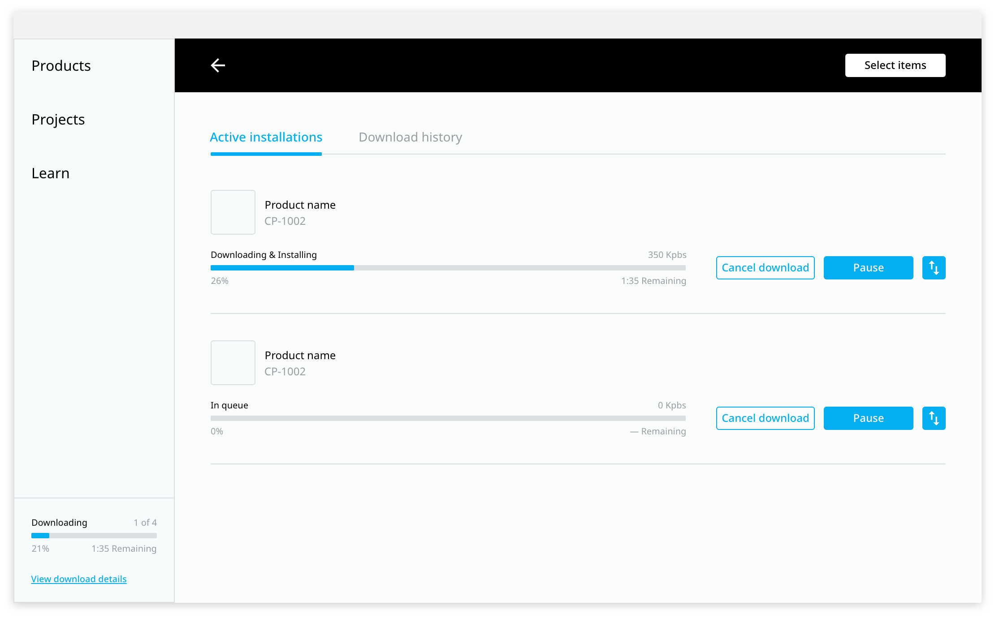

Detail of download/ installation status.

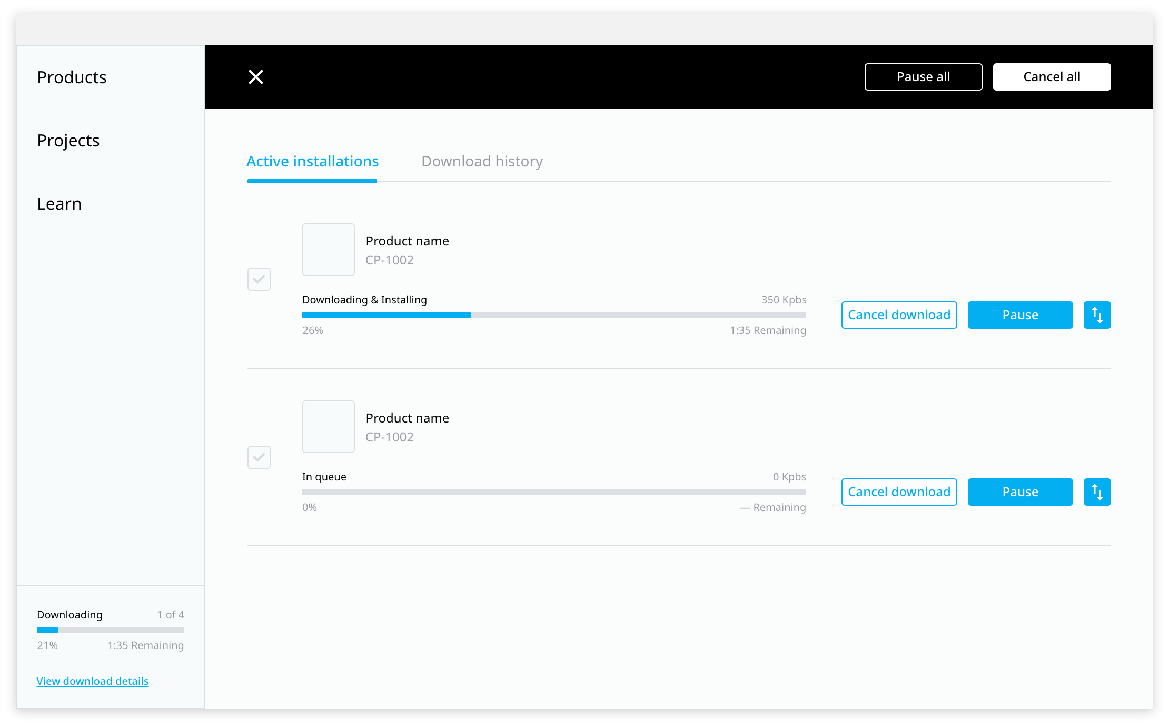

Selection mode of products in queue to perform group actions.

# Tech Stack

Since Rockwell Automation already has a tool that enables the user to install different software products, we evaluated the state of that tool, the Common Installer, and a new approach that is aligned with the current RAIDER tech stack.

Here we have two clear and opposite options: Build on top of the Common Installer of RA or design and implement a new program with RAIDER tech stack and migrate useful code from the Common Installer.

## Build on top of the Common Installer

The main idea is to leverage on the common installer implementation and extent it to a full HUB. The common Installer is a tool that intend to serve as a common installation program that offers the same UX for a variety of Rockwell Automation’s products.

Some of the features that provides are the following:

* Activation can be enabled by the common installer, but it is not part of it.
* Resource DLL allows changes in UI.
* Allows adding plugins with several available hooks in the install process (when loaded).
* Allows setting allowed and not allowed OSs.
* Allows adding prerequisites (external dependencies).
* Allows adding dependencies (Rockwell Automation dependencies).

Features not allowed:

* Logix Designer has no way right now to deploy a patch. They deliver the entire ISO to the end user.
* Ask all the questions upfront to avoid intervention (REQUESTED BY END USERS).
* Unattended deploy (REQUESTED BY END USERS).
* Does not allow to download packages as of today (this can be done using plugins but it is a little messy). All assets are part of the ISO.

Common Installer Release status:

* There is active development on top of it.
* Version 3 is in development.
  + Updater to detect new versions of each product.
  + Repair feature.

**Technology Stack**

The Common installer has a Bootstrap process that is the one that starts with the execution of the program. This process checks the existence of a .NET installation, if it doesn’t exist in the current PC then it triggers an installation of the needed framework, the binaries for this is delivered with the common installer package.

The program for the bootstrapper is fully written in C++.

When a valid .NET installation is available the Bootstrap launch a .NET C# program that is the actual common installer application. The common installer application reads an xml file containing the configuration of the specific software delivered to the client.

This xml file provide the necessary information to install the software product, some of the information include:

* Dependencies. (With other Rockwell Automation products)
* Prerequisites. (Frameworks, DBs)
* Supported OSs.
* Version.

**Known issues**

The common installer UI is implemented using WPF framework, WPF employs XAML, an XML-based language, to define and link various interface elements.

On December 4, 2018, Microsoft announced releasing WPF as open source project on GitHub. It is released under the MIT License. Windows Presentation Foundation has become available for projects targeting the .NET Core framework, however, the system is not cross-platform and is still available only on Windows.

As for now, the common installer only supports MSI and EXE install technologies, when new install technologies are available.

Another limitation is that for obtaining the available to install software the common installer uses an XML file which contains a list of installable Rockwell Automation software.

**Summary**

Advantages:

1. Re use of already implemented code (Not all, but much of it, ie: PCDC API integration, MSI management).
2. C++/C# expertise of the team.

Disadvantages:

1. .NET requirement.
2. WPF is not cross-platform and is still available only on Windows.
3. WPF is an old technology, for which reason Microsoft suggests other frameworks.

### 

## New implementation aligned with RAIDER

This approach involves a fresh start in several aspects and having more freedom of designing a state of the art product.

The first benefit is that RAIDER is being built using Electron, which enables to build cross platform desktop apps with JavaScript, HTML, and CSS.

Another important fact is that having freedom of design allows to start the construction of the HUB with a clear north in mind, enabling to remove some redundant flows and merge them into a single UX. For instance, the first time that a customer acquires Rockwell Automation software the binaries are delivered using an email and in the other hand when an update is downloaded the customer must use the PCDC platform.

**Summary**

Advantages:

1. Aligned with RAIDER Tech Stack.
   1. If Rockwell Automation wants to continue with the HUB the task can be assigned to a RAIDER POD.
2. Cross-platform.
3. Electron builder for build and packaging.
   1. MSI, EXE, linux packages, among others.
4. State of the art technology.
5. Look & Feel from RAIDER.

Disadvantages:

1. Not direct API for handling MSI installers (most of Rockwell Automation are of this type).
   1. Even though using interoperability with C++ this problem can be bypassed.
   2. MSI management can be reused because it is implemented in C++.
      1. Overhead implementing the PLI (Programming Language Interface) javascript/C++.
2. Overhead in migrating existing C#/C++ code to javascript.

# Conclusion

We consider that having such a diverse ecosystem of software products and also providing many different channels for getting them, contribute to generate a not desired burden to the user.

Is in this sense that the concept of a HUB comes to play to unify the diversity so the user only need to focus on a single tool with very well defined flows.

The main aspect that have to be addressed in a future implementation of the HUB is that, as it embraces multiple Rockwell Automation products and services, the interactions between them have to be very well defined and clear.

Even though designing the HUB to fit into de Rockwell Automation ecosystem, some services would need to be refactored to adapt to the new approach, for example, defining some microservices to handle certain interactions as obtaining the binaries for installing a product.

**Accepts**:EULAs,

**Downloads**: products

**Consumes**:Extensions, Libraries, Learn

**Launches**

**Launches/API?**

**IAM service**

An example the HUB interactions with Rockwell Automation tools and services.

To summarize the following are the main benefits if Rockwell Automation decides to implement the proposed HUB:

1. Unify the product life cycle UX into a single one.
2. Ease the usage of the products.
3. Reduce the overall learning curve.
4. Make complex and unnecessary processes transparent to the user.
5. Centralize the management of multiple remote computers into a single admin.
6. Sharing of binaries throughout the private network.

Finally, based on all the information collected in this document, we recommend Rockwell Automation to construct the described HUB and provide them to the customers with the hypothesis that it will generate a significant positive impact with the improved user experience.